The purpose of this document to show a step-by-step process for setting up a server side part of the MLA. The document is created on 11/24/17 by **Paril Shah**. So, in the future the below steps might be changed. The entire document is divided in 3 parts, 1.) AWS EC2 setup, 2.) AWS RDS Instance setup, and 3.) Deployment.

**AWS EC2 Setup**

1. Sign up as a new user from <https://aws.amazon.com>
2. Click at “Create an aws account”.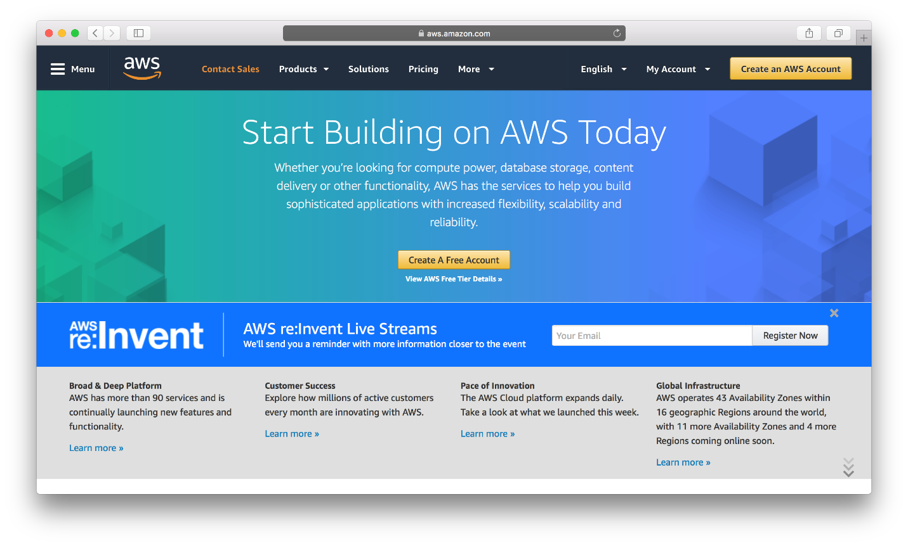
3. Fill all the required details.

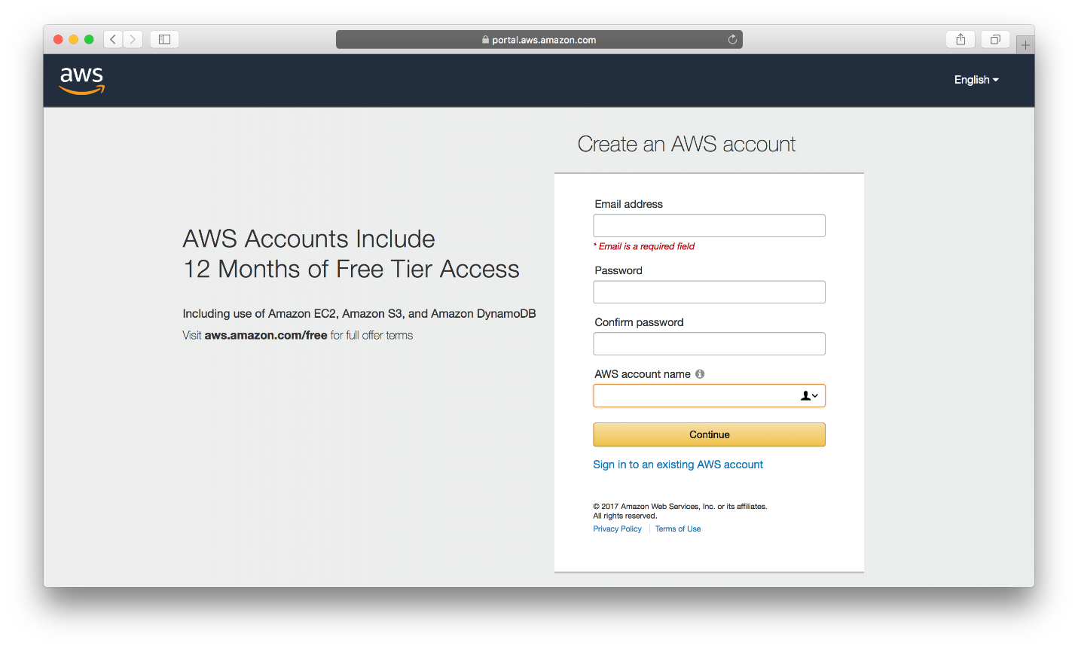

1. Add your personal information, if you select account type “Personal”.

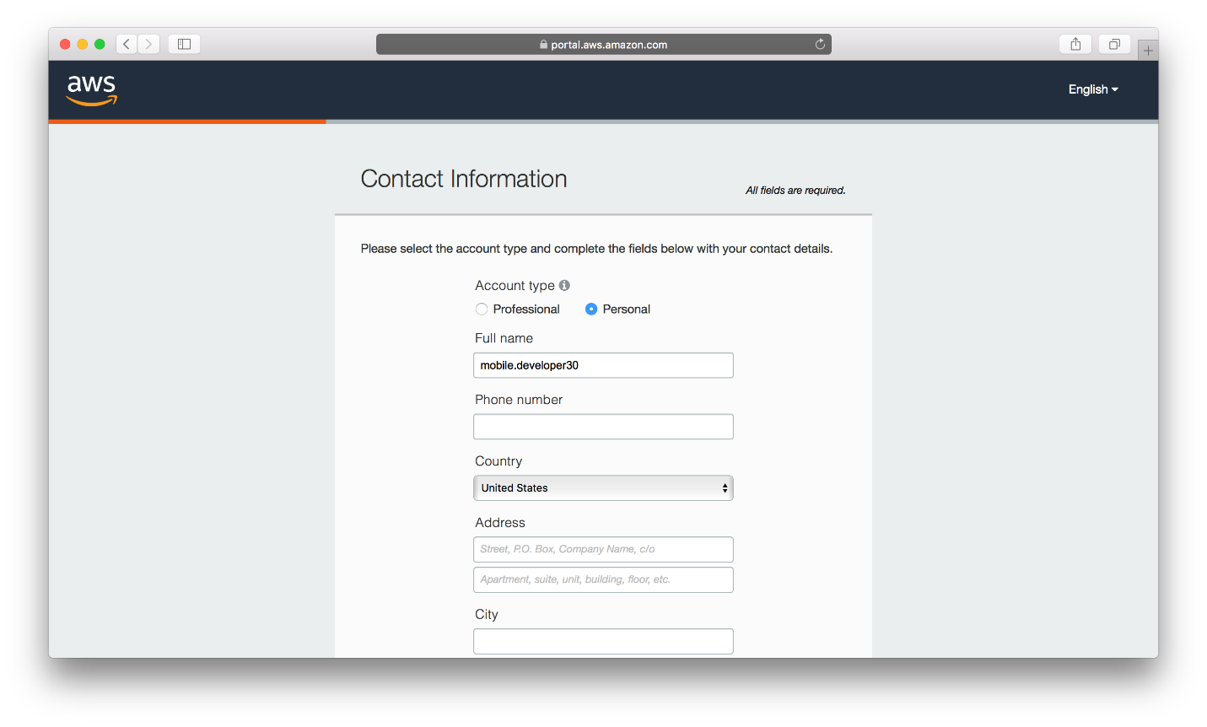

1. Add Payment Information.
2. Complete phone verification step.
3. Select a support plan (I have selected Basic Plan)

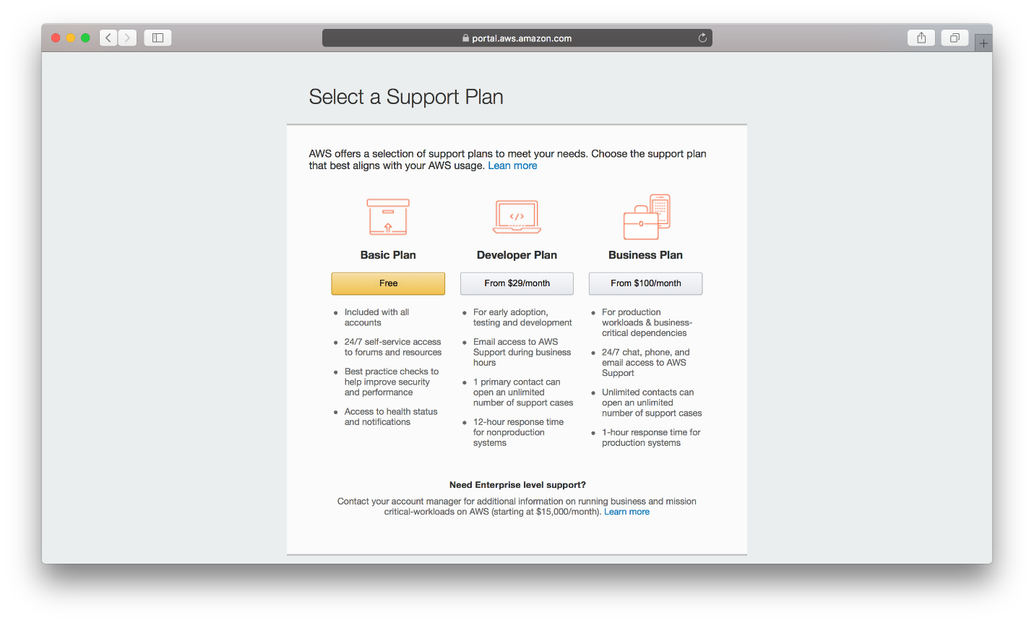

1. In the next step, do a sign in console.
2. After logged in successfully, change the region as shown in the below screenshot,

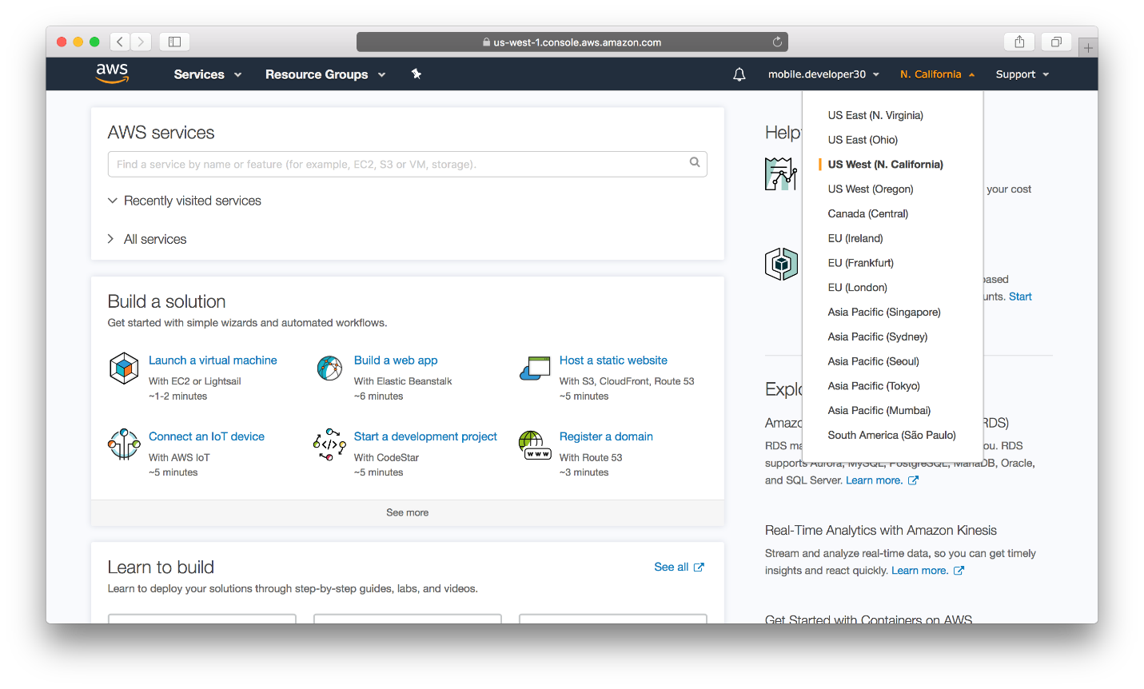

1. Then selects “EC2” from All Services section.

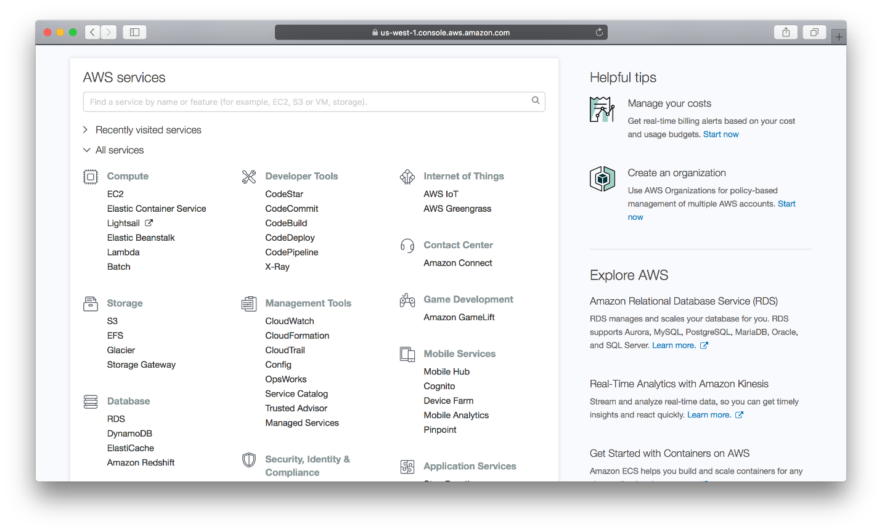

1. Upon clicking “EC2”, the user will be redirected to resources screen. From here, clicks on “Launch Instance”, the button with blue color.

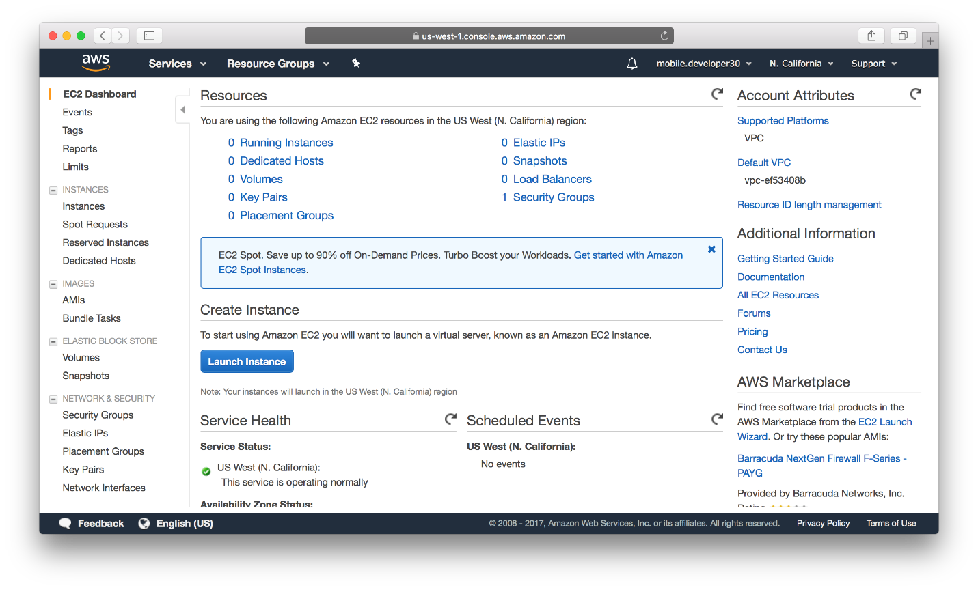

1. Choose an image. I am using “Microsoft Windows Server 2012 R2 Base”.

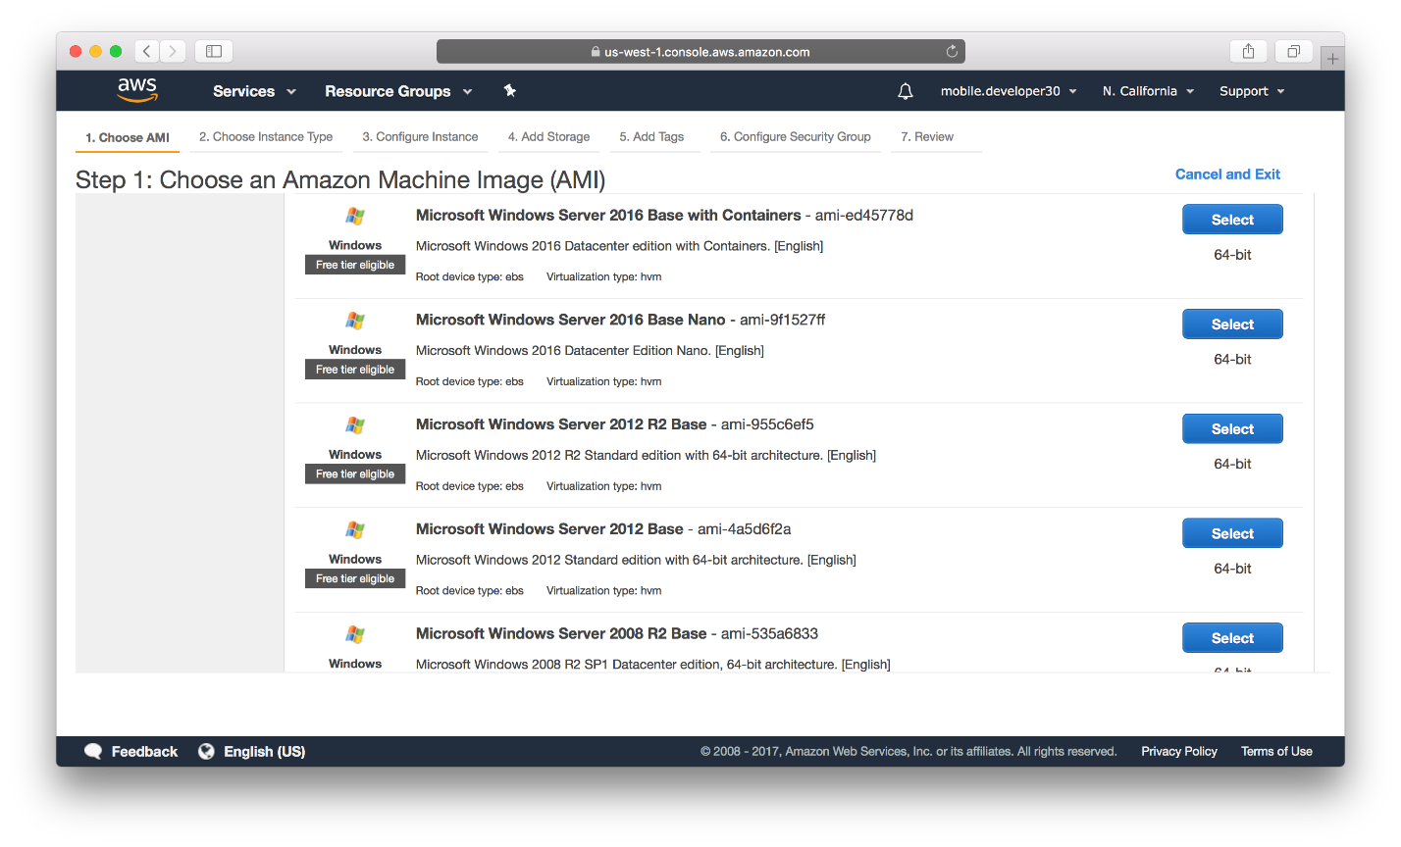

1. Choose an Instance Type. I am using t2.mico for the MLA. Then you have 2 options, 1.) Review and Launch, this option is selected when you have already the desired configuration available, and 2.) Next: Configure Instance Details, this option is selected while you need additional settings. So, select the 2nd option.

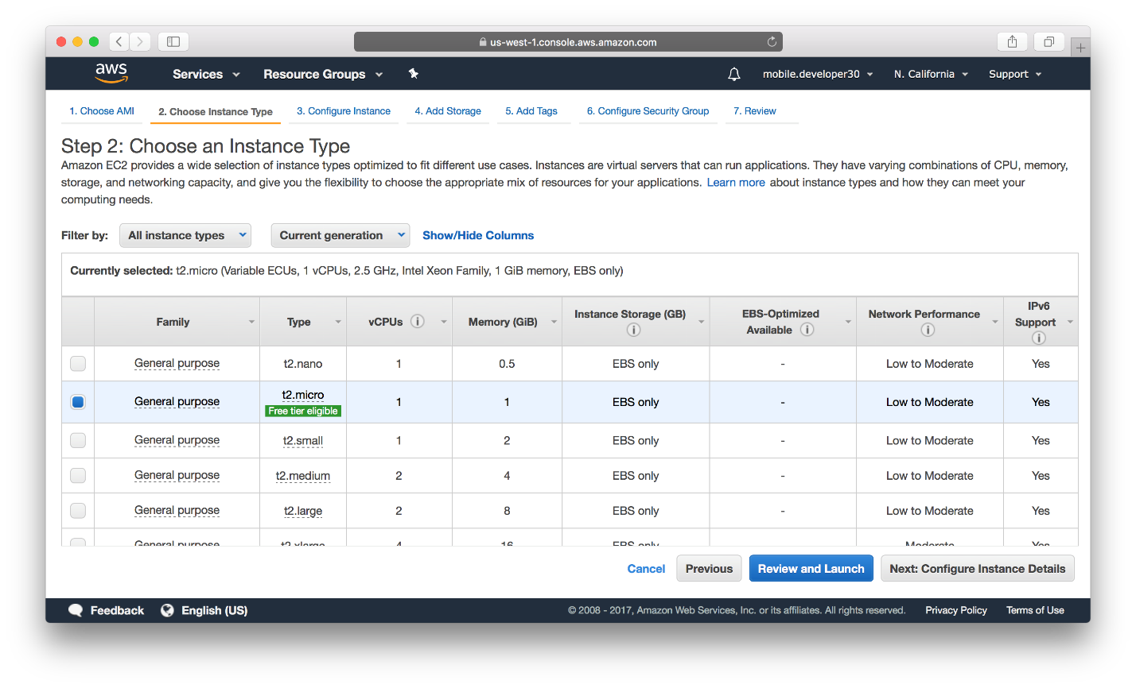

1. Now add configure instance details, I kept all the default configuration.

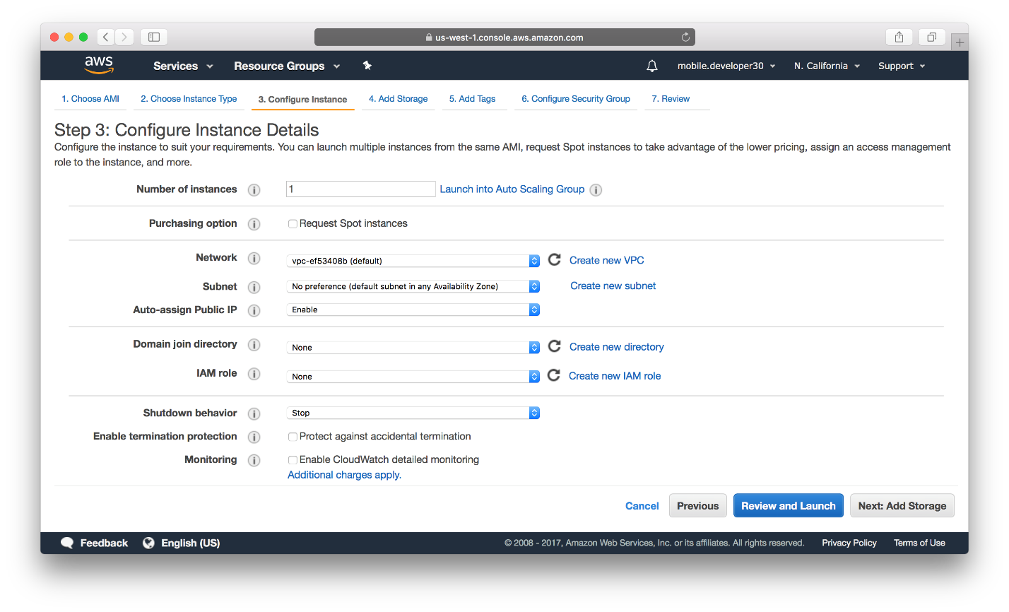

1. In this step selects, the storage you require. I kept the 30gb which is available for Free tier.

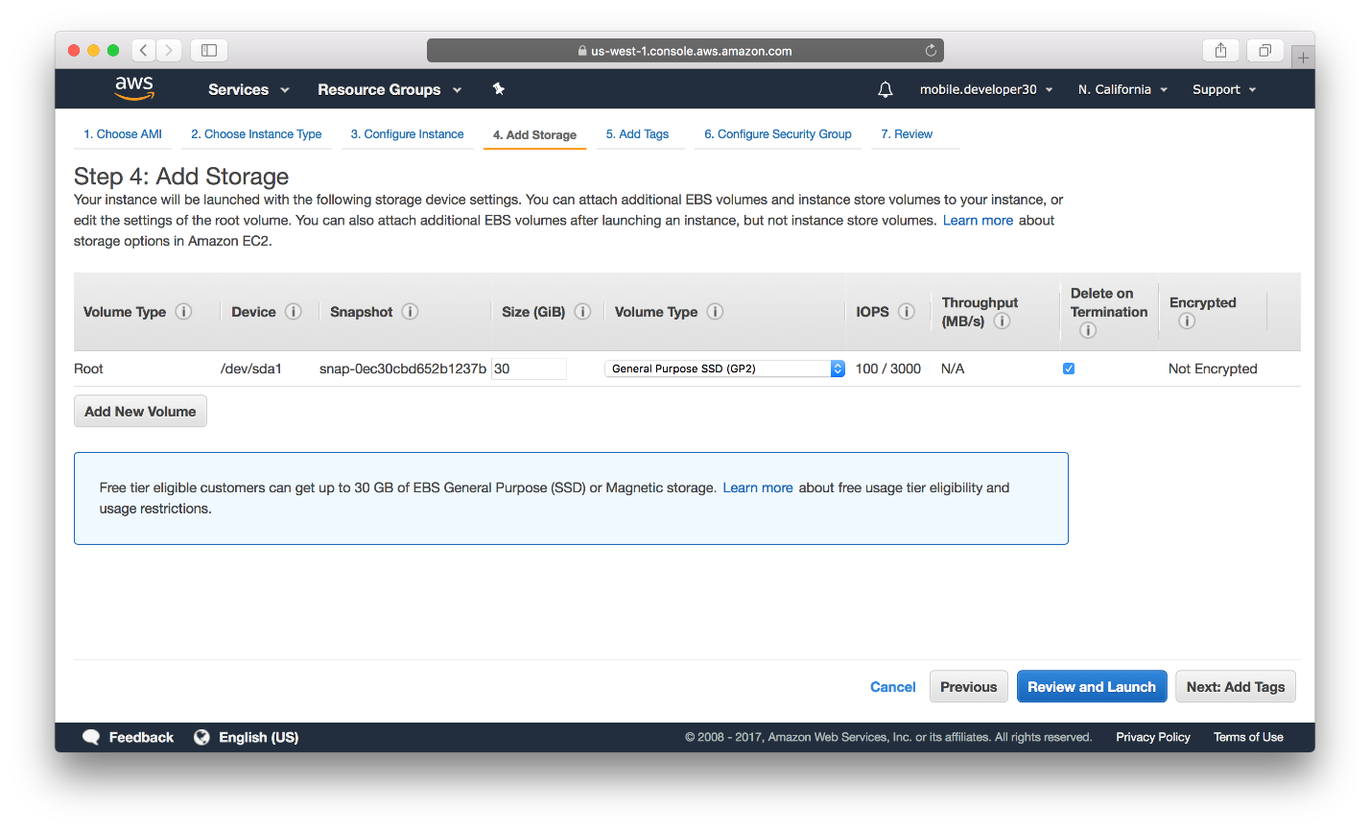

1. Add tags

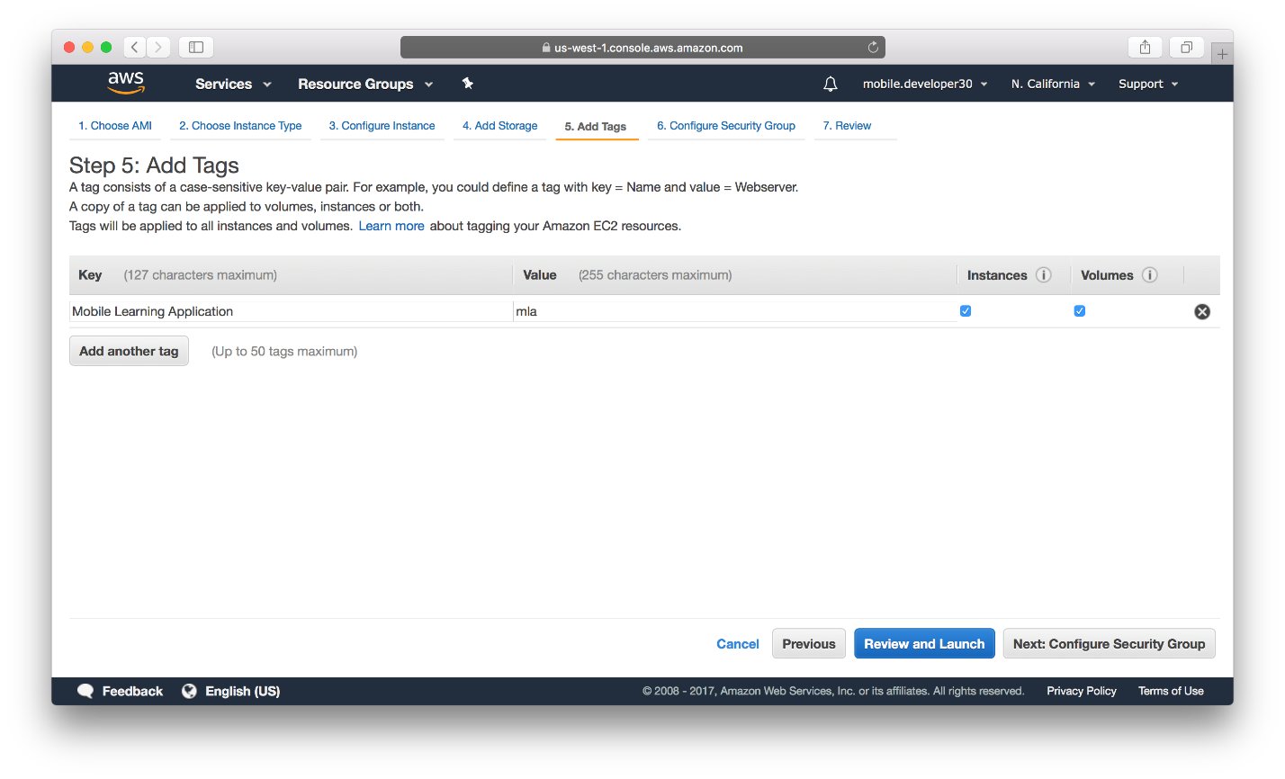

1. Add Security rule. I kept the sources “Anywhere” for different Rules Type: RDP, Custom TCP Rule, HTTP, HTTPS, and MS SQL. For “Custom TCP rule”, make sure to set the port number to be 8172 while everything else set the same as other protocols.

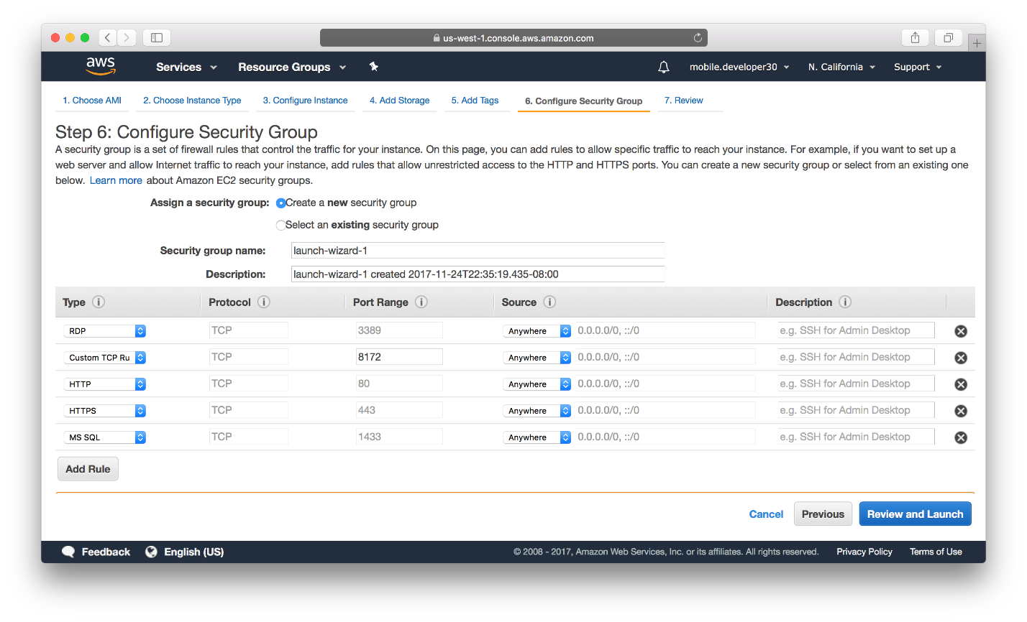

1. Upon Step 7, Review all the details and Launch the instance, if all the information is correct. Upon launching the instance select, it asks to add/select a key pair.

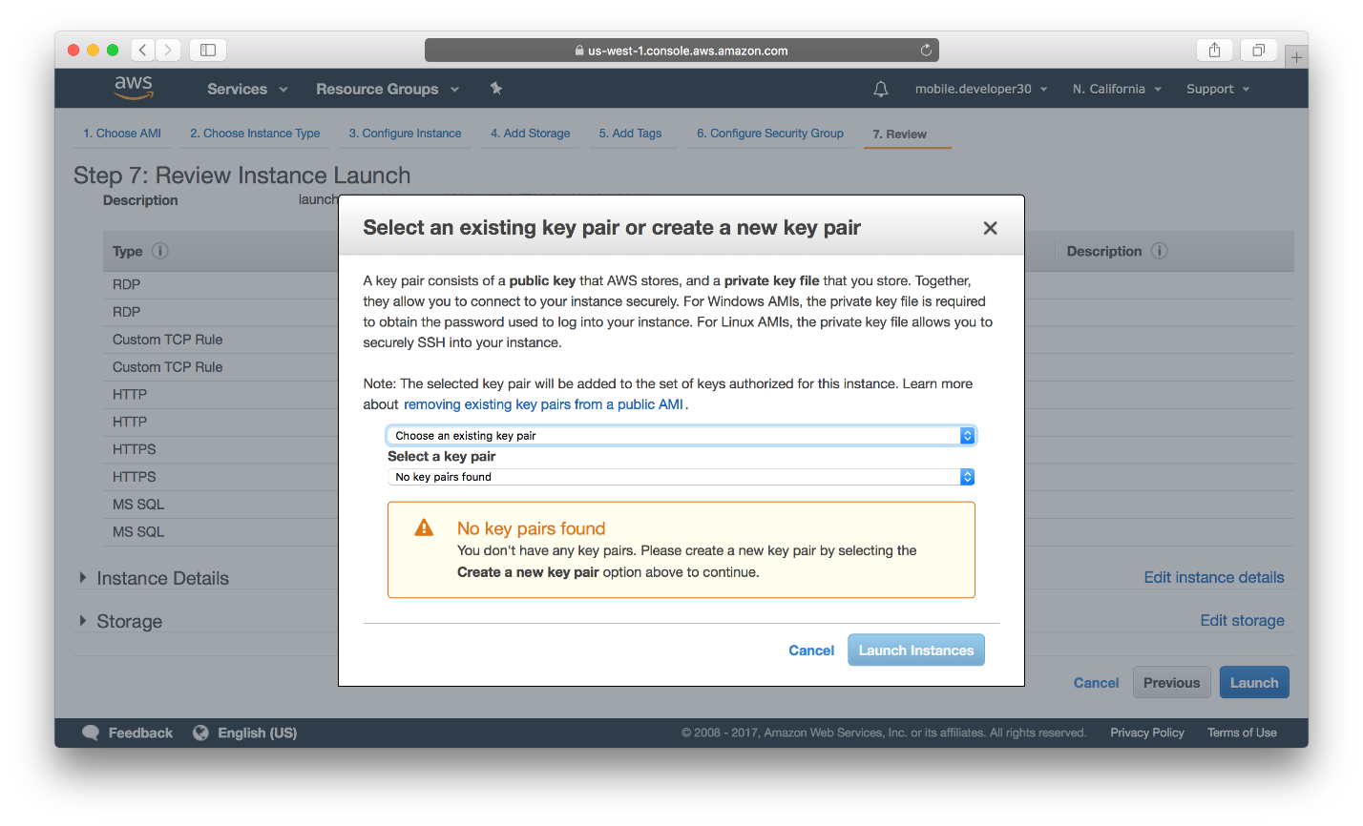

1. I wrote “mla”. Download the Keypair. Keep it safe with you. It is the public key for the instance. When you want to connect with the instance, you need this file to decode the password of instance. 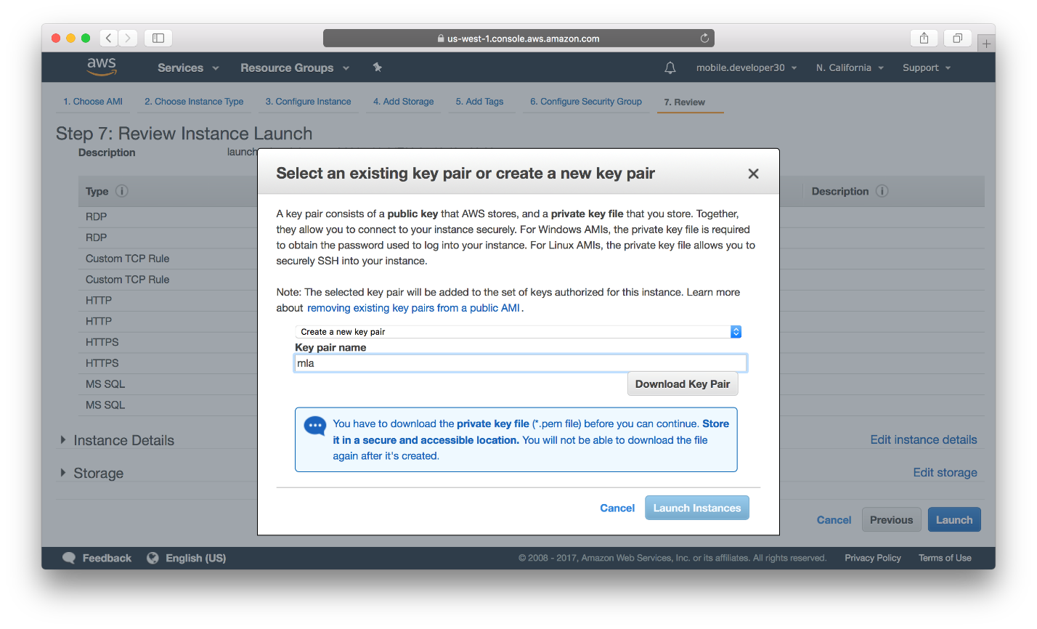
2. Upon Launching the instance, you can see below screenshot,

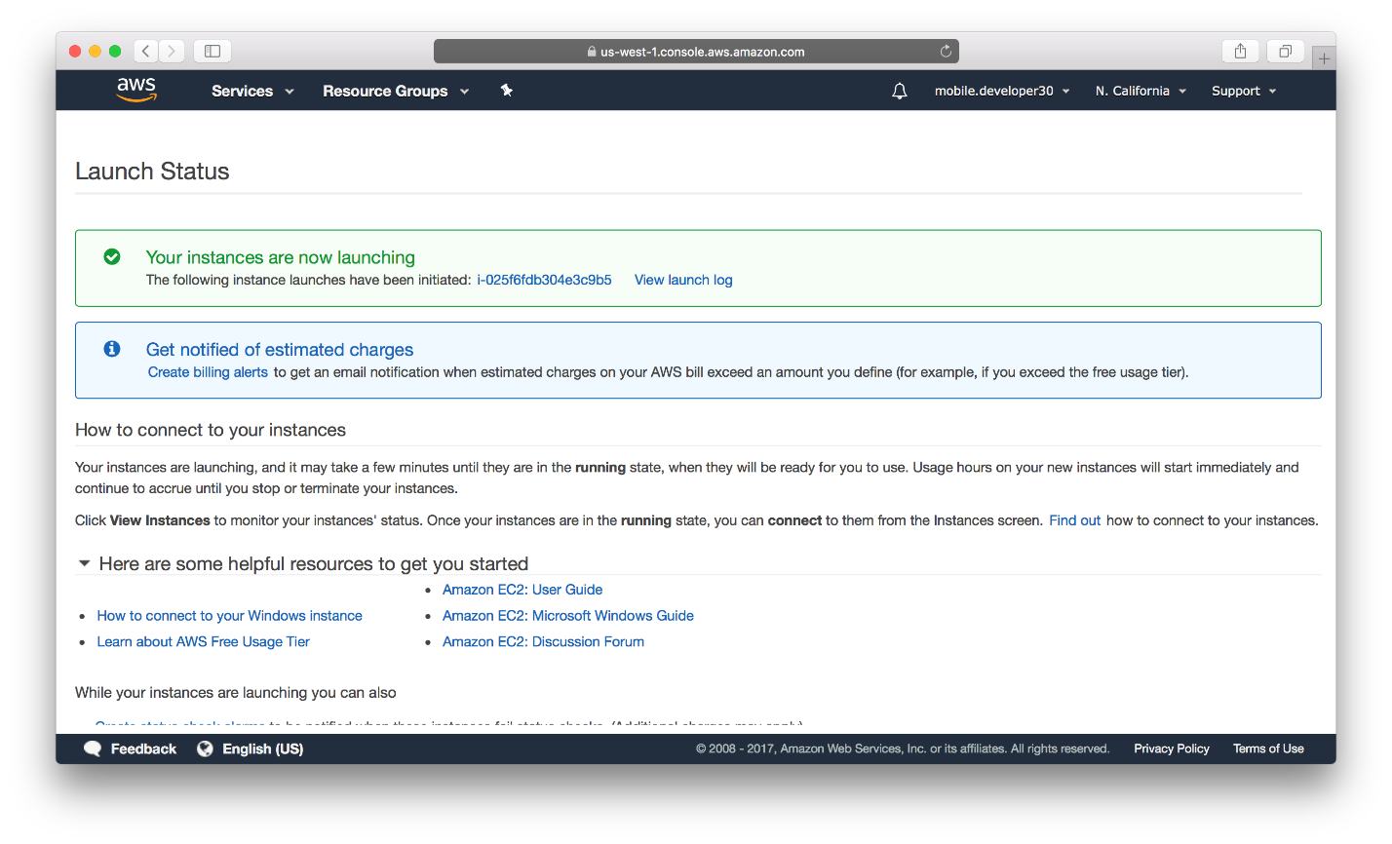

1. Upon clicking View launch instance, the system shows all the instances created by the user. Under the description tab, there is a Public DNS (the communication endpoint), which is the URL to reach to the Host Machine.

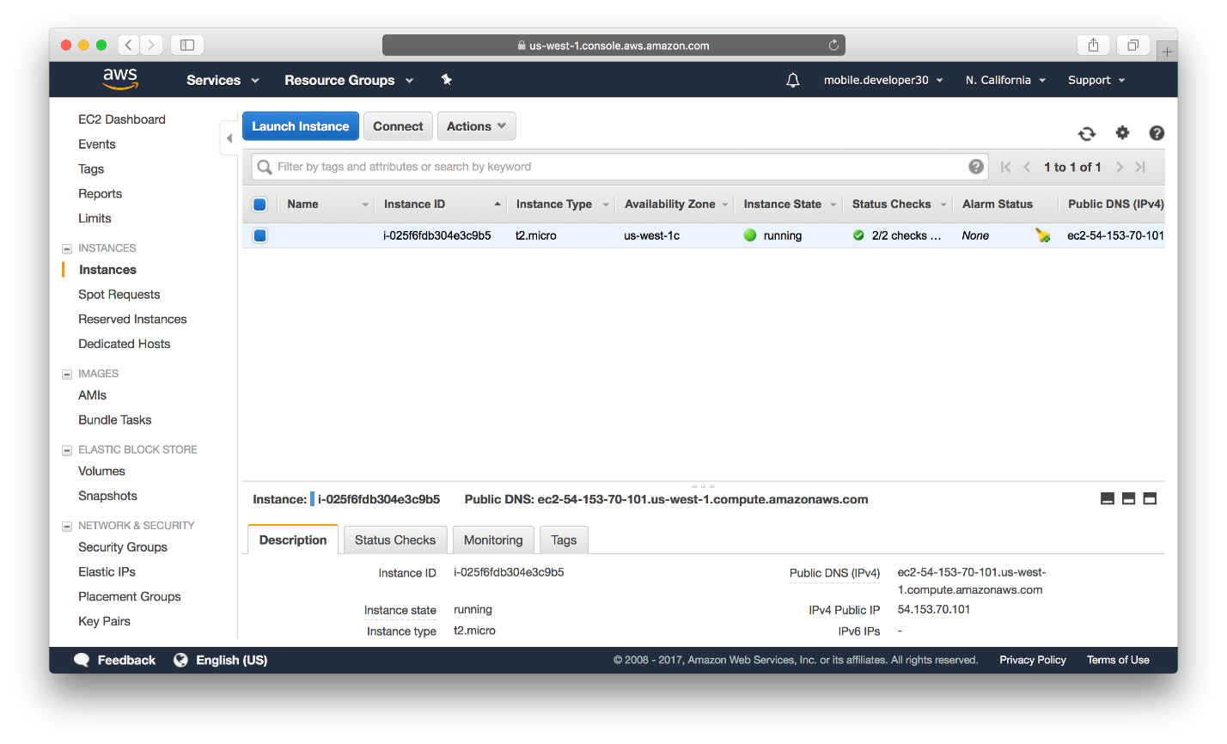

**AWS RDS Setup**

We have already set up an EC2 account, which is a computing server. Now, we will set up database server RDS,

1. To set up a RDS, selects “RDS” under Database section from All Services section.

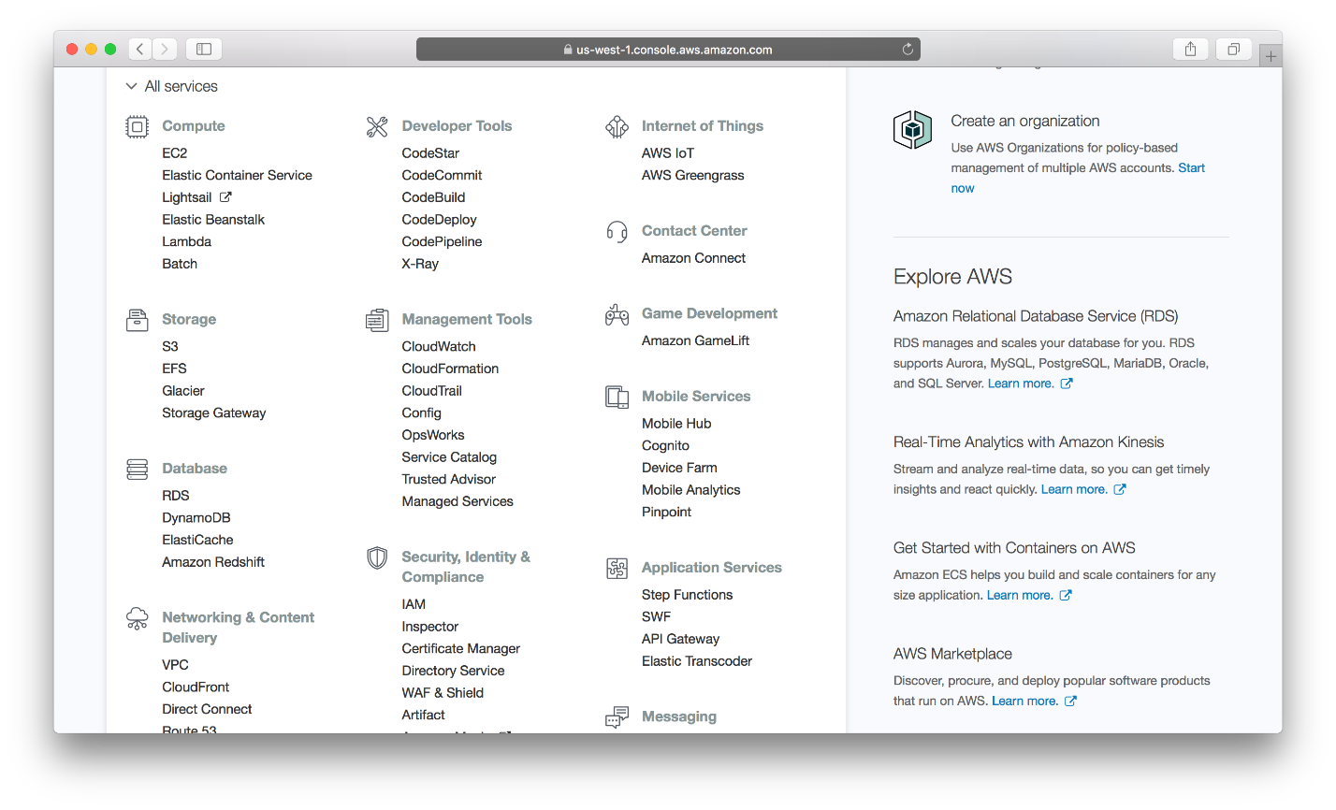

1. Select a Launch Instance. I selected the check box which helped me to choose only free instance. Selects Microsoft SQL server and SQL Server Express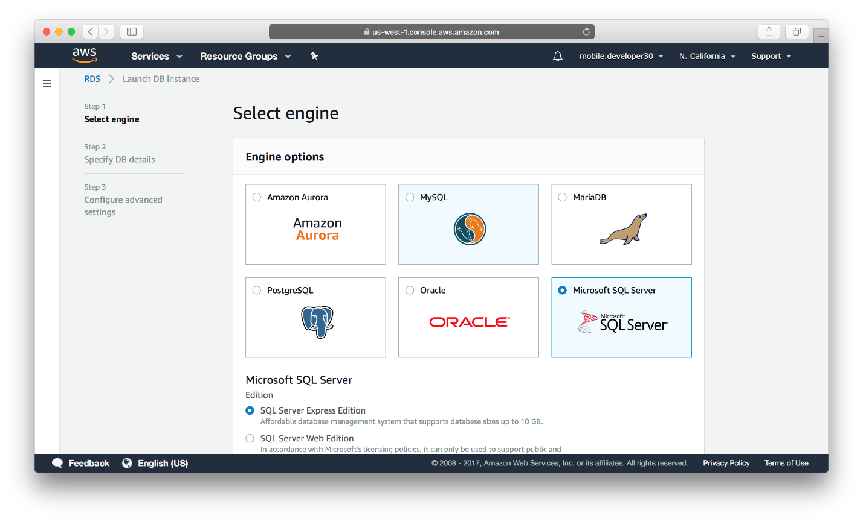
2. Then add DB Details. I kept the valid settings for the free tier. Then add DB instance identifier, Master Username, and Master Password. Last, press the “Next” button. In the screen below, accept the provided DB image and the corresponding settings.

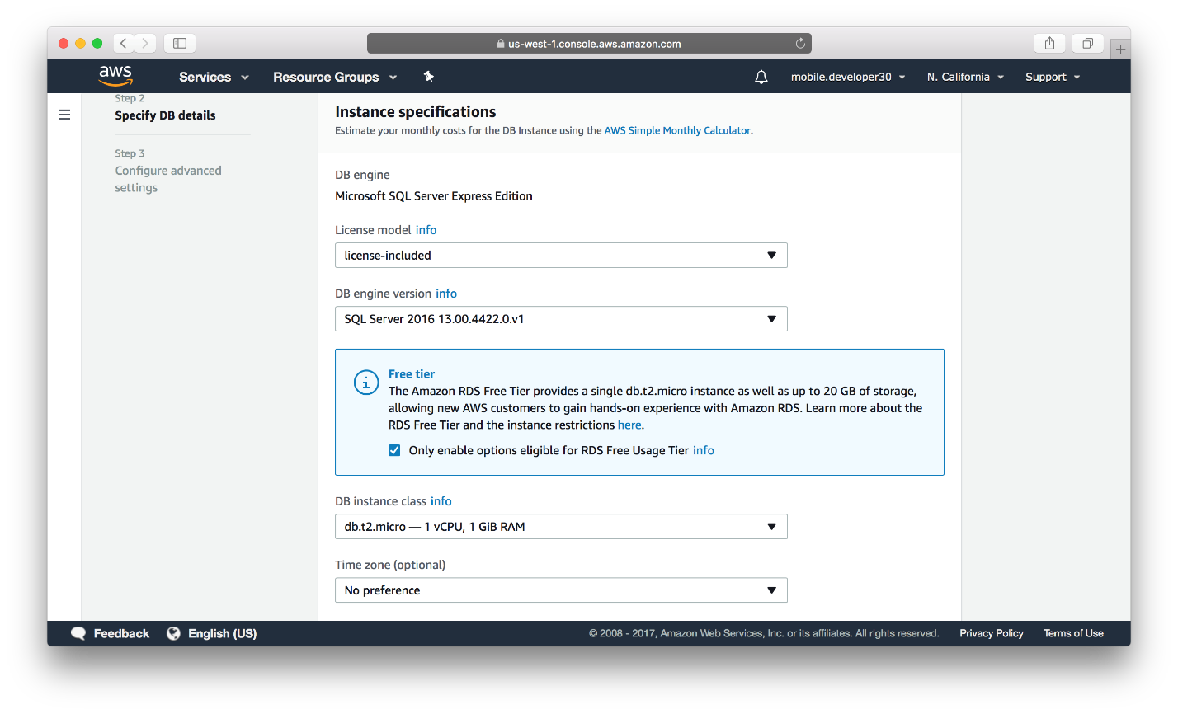

1. Then adds “Configure advanced settings”. Here selects the preference as per the requirement. For the current setup, follow the settings in the following screenshots, and then “Launch DB instance”. Note that, now under the same VPC ID related to the AWS user, there are two security groups that have been set up, one for EC2, now the default VPC grop for RDS.

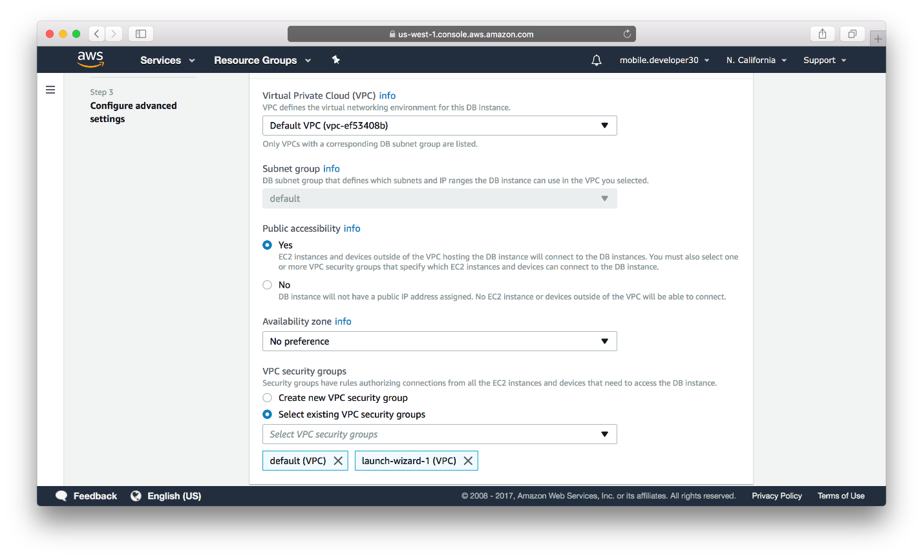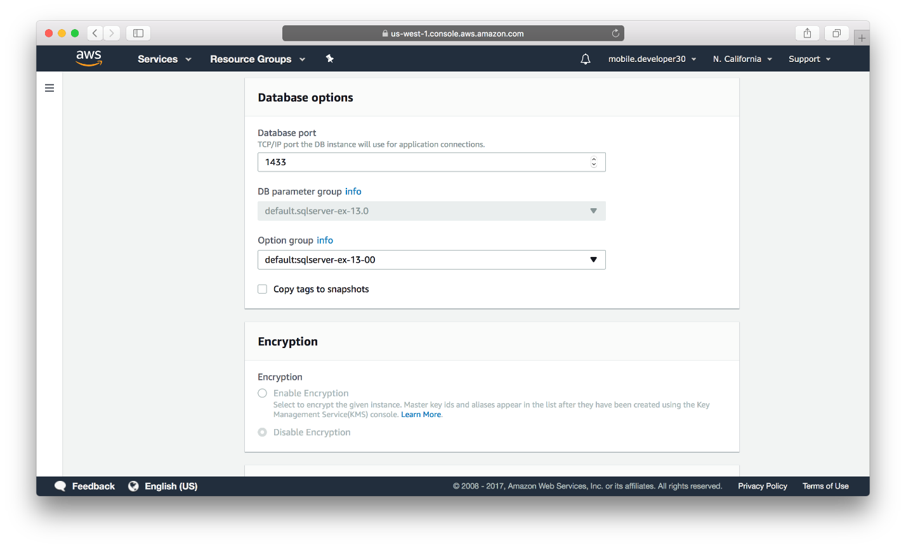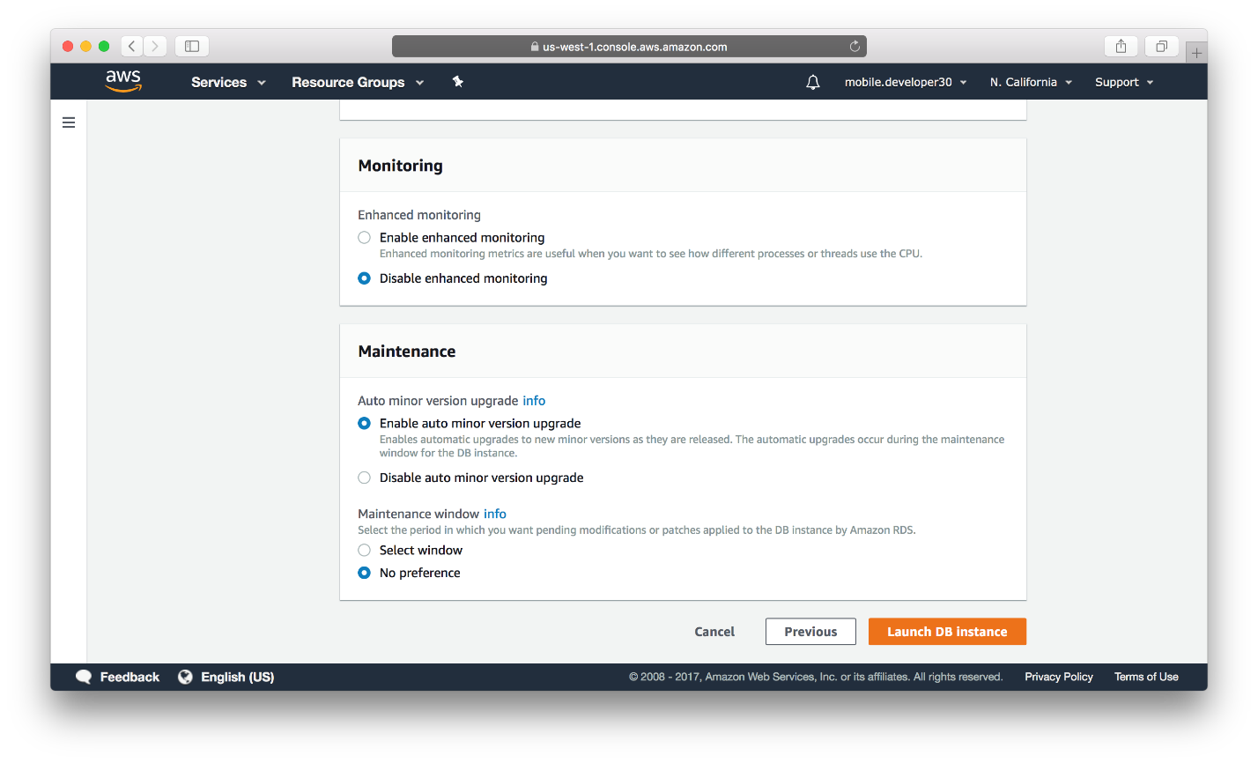

1. After creating a successful instance of the DB Server, the below screens will be appeared,

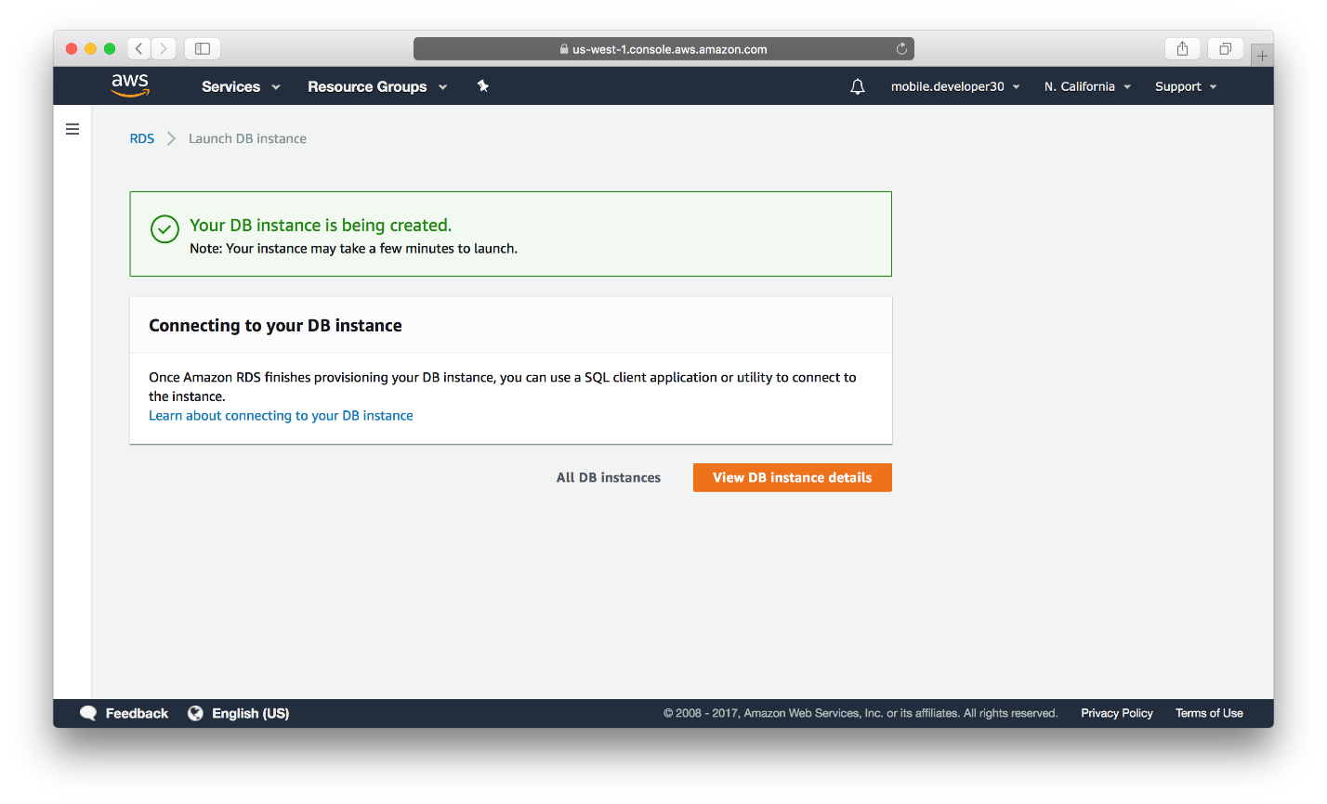

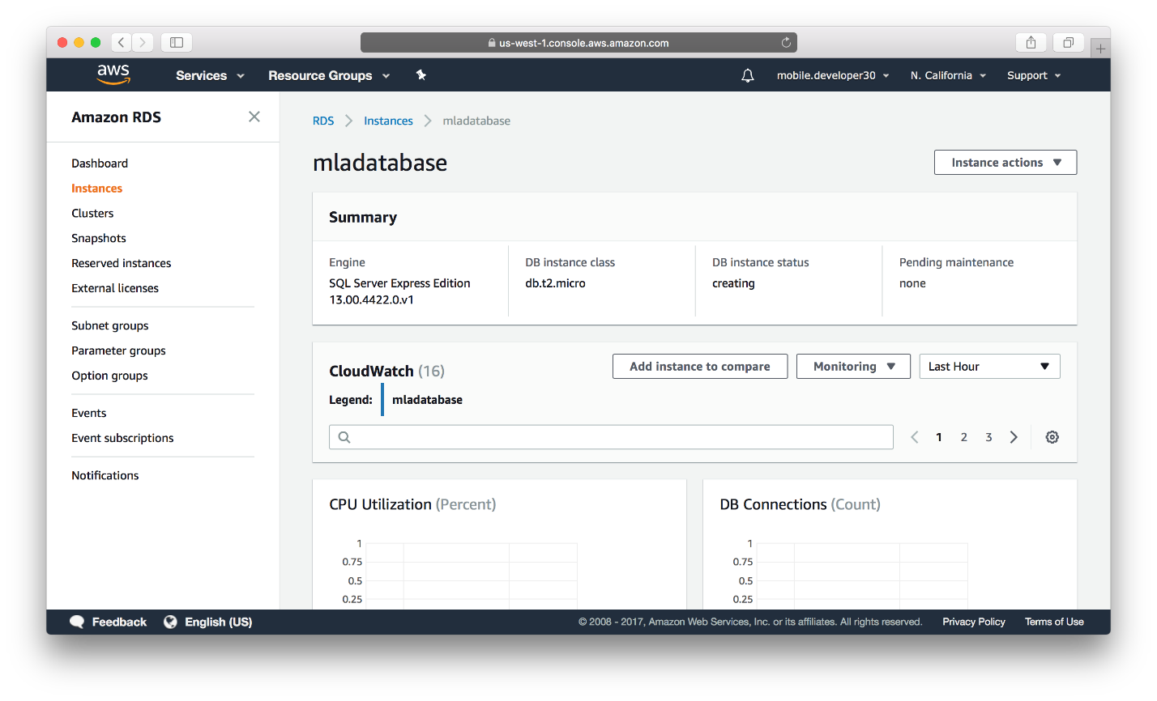

1. After a few minutes, under security network section, End point will be appeared. This is an end point by which a user can access the database.

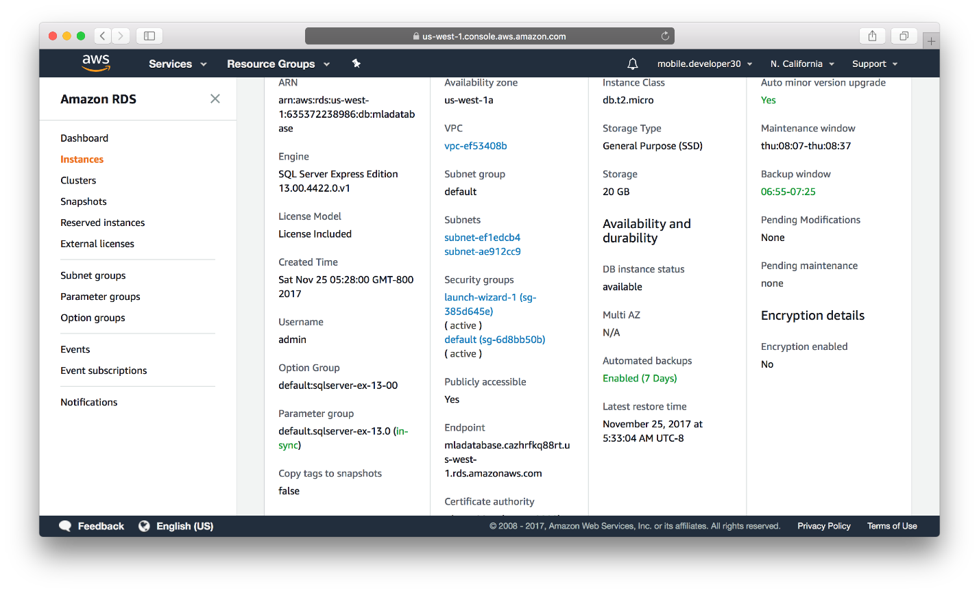

**Deployment at AWS**

First, we will create a new database in SQL Server Management Studio. Following that, we need to connect DB with the MLAWebApi from Visual Studio. Lastly, we need to publish at AWS. Note that you need to install the same version of SQL server on the local site, in order to use SQL Server Management Studio properly.

* **Create a new Database**

1. Open Microsoft SQL Server Management Studio. As shown in the below screenshot, from “Object Explorer” -> select “Connect” -> select “Database Engine”.

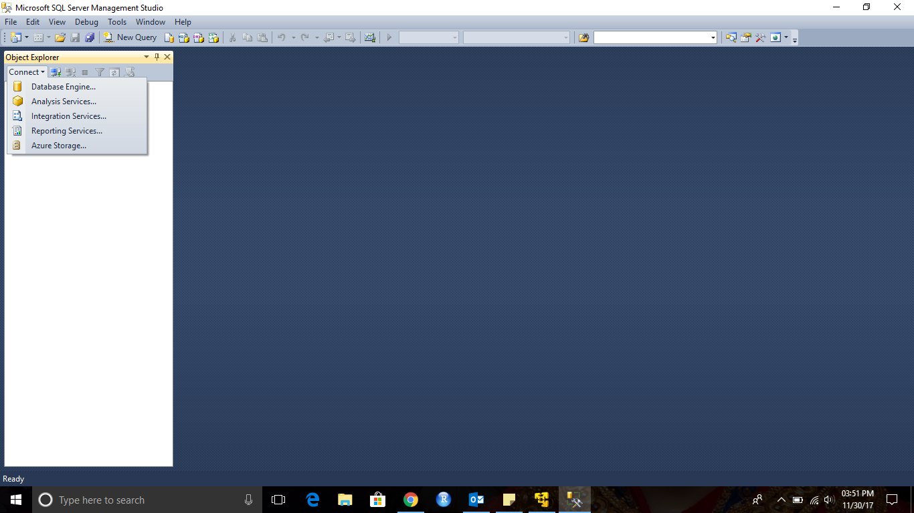

1. Add the URL of the database server. You can get the URL from AWS RDS. Add your credential. The endpoint is in the form of “mladatabase.cnb0lihdfsiq.us-west-1.rds.amazonaws.com:1433”. When entering the url, make sure to change colon to comma, ‘,’ that separates the DNS name and the port number.

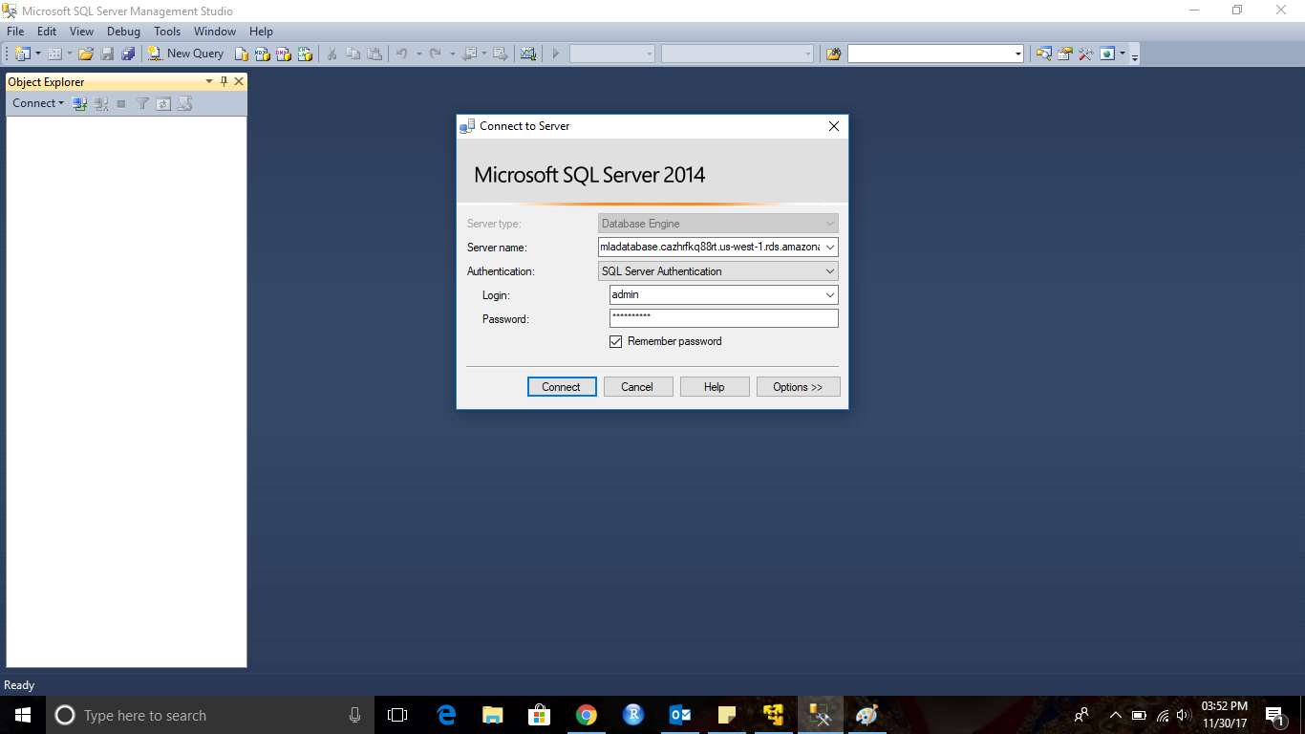

1. After connecting successfully, you can see the newly created DB server instance (remotely on RDS) in “Object Explorer”.

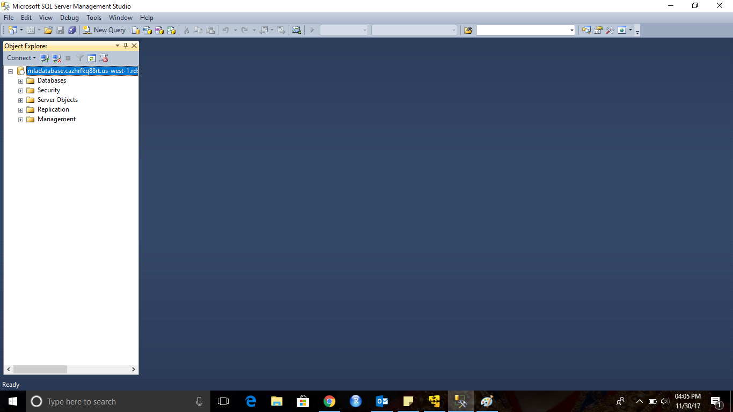

1. As shown in the screenshot below, right click on “Databases” folder, and select “New Database”.

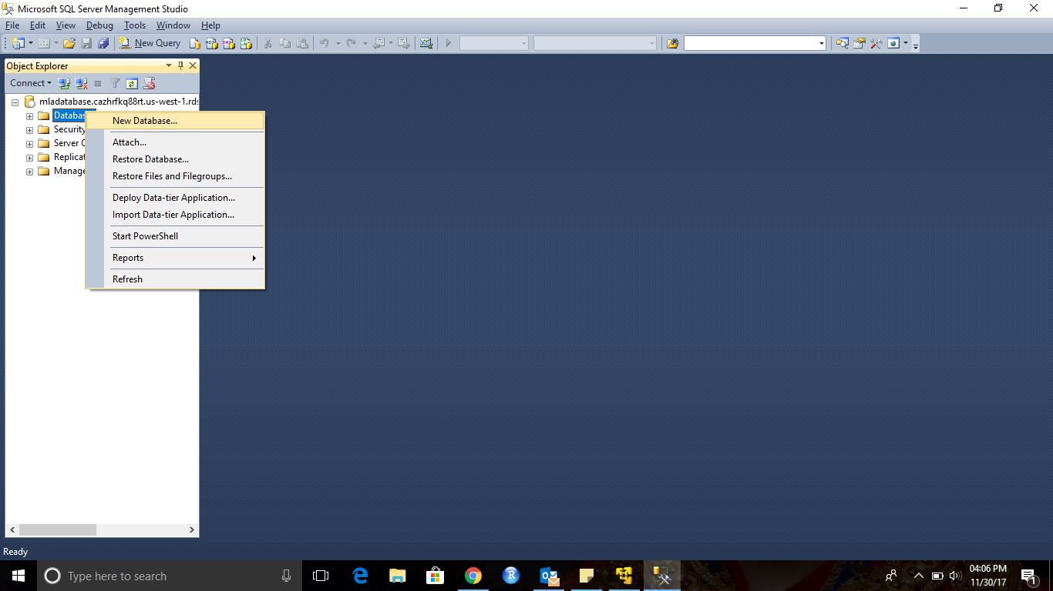

1. As shown in the screenshot, provide a Database name and click OK.

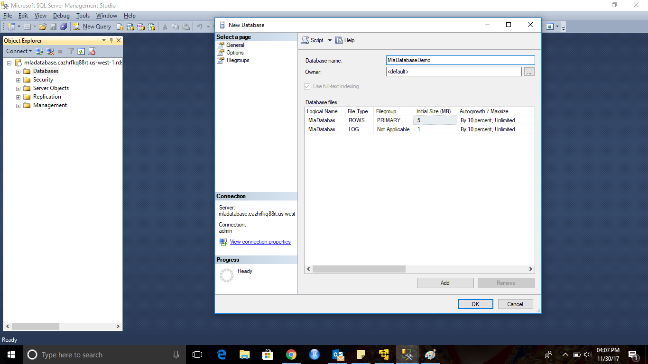

1. As shown in the screenshot, you can see a newly created DB in “Object Explorer”.

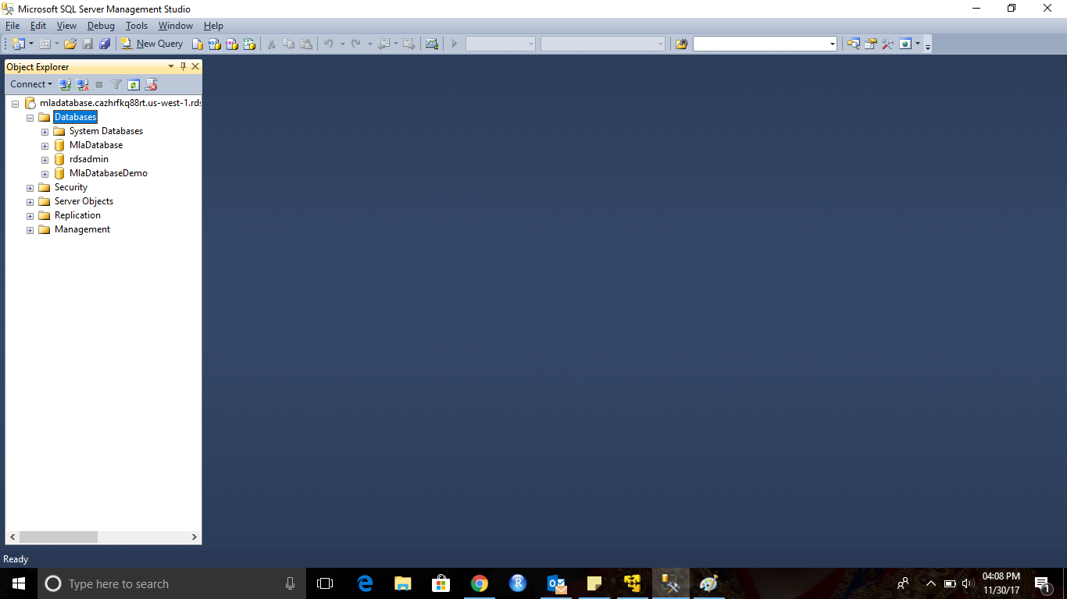

1. Open the Script.sql file in the SSMS, then execute it to create and populate the database tables. In the script.sql file, make sure that the DB name in the first line is the same as the name of the database you created earlier.

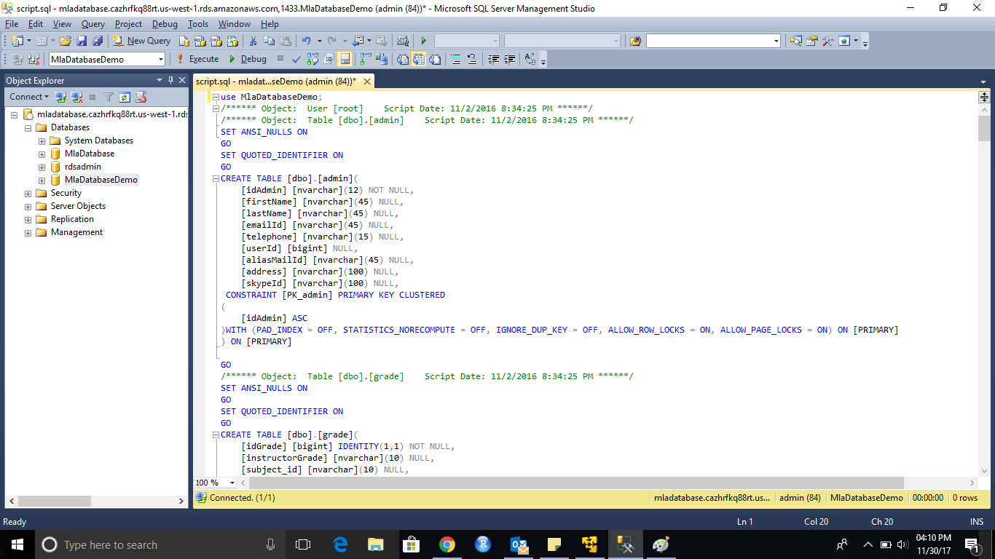

1. If successful, the IDE shows the following message.

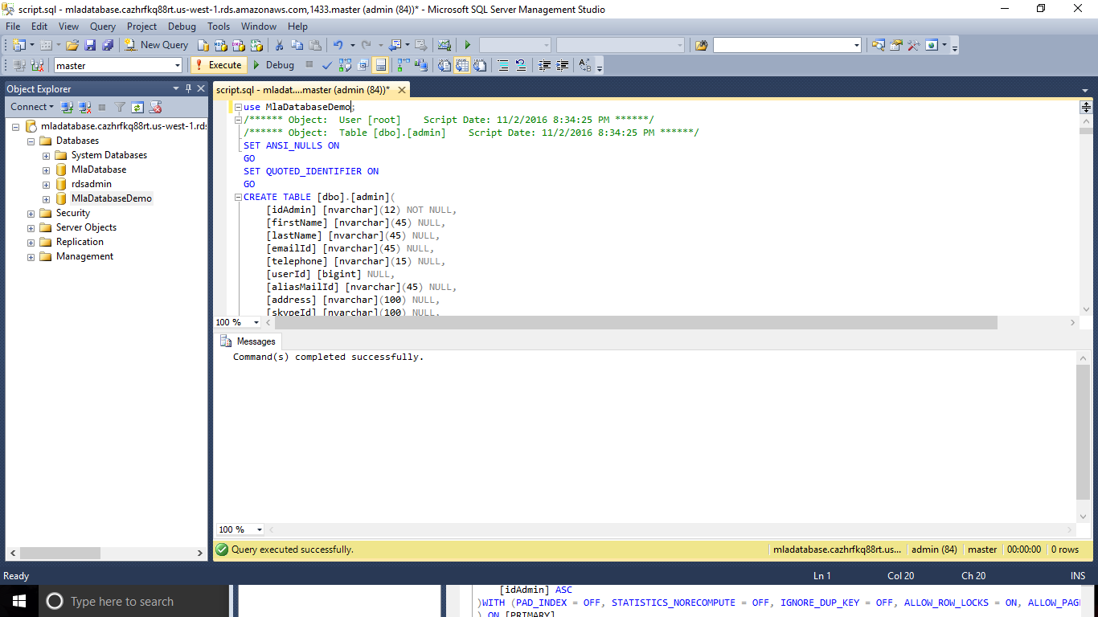

1. In the screenshot below, expand the DB. You can see a list of Tables from “Object Explorer”.

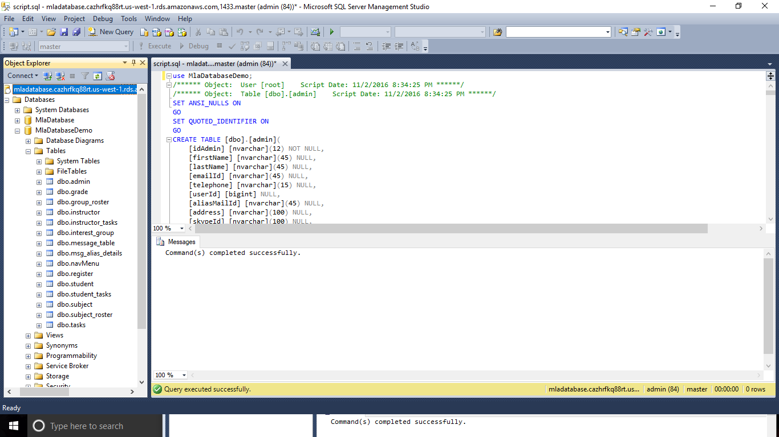

1. After creating a successful DB, we need to configure the connection between the database with the application/service (in this case, it is MLAWebApi) that has been or will be deployed on your EC2 server.

* **Deploy Application to the AWS EC2 Instance**

After creating our data layer at Amazon RDS, we need to upload our application onto the Amazon EC2 server we created earlier. For that make sure you have the valid environment setup,

1. Firstly, we need to install IIS on AWS EC2 instance. To make it easy, you can you Windows Remote Desktop to connect to your EC2 instance, then follow the link to set up IIS on your EC2 instance.

<http://thesolving.com/server-room/how-to-install-and-configure-iis-on-windows-server-2012-r2/>

**NOTE:** During IIS installation, don’t forget to install ASP.NET and .NET Framework 4.5.

Follow the screenshots below to add necessary roles and features to IIS,

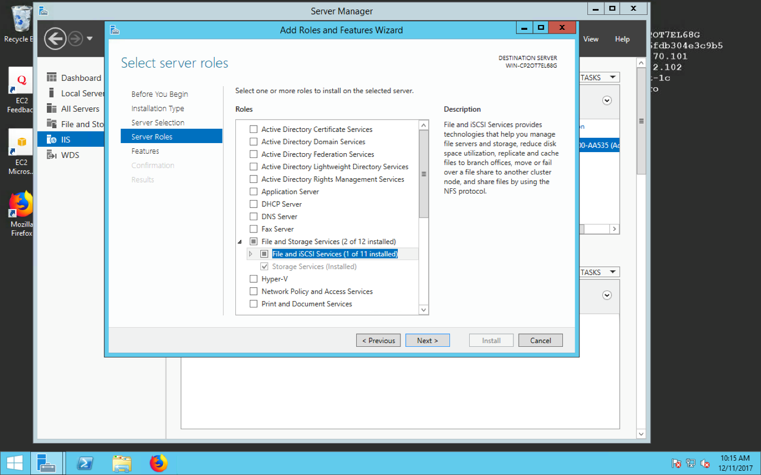

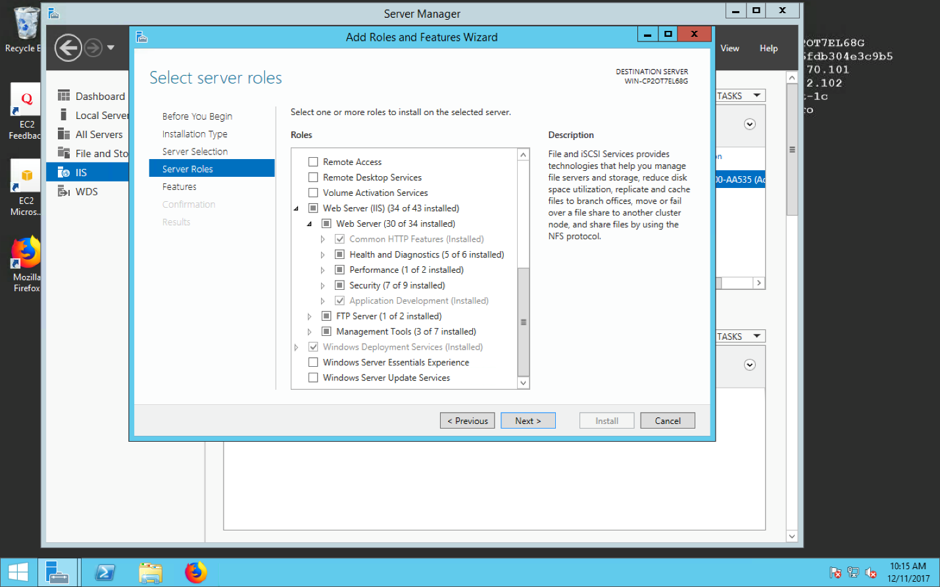

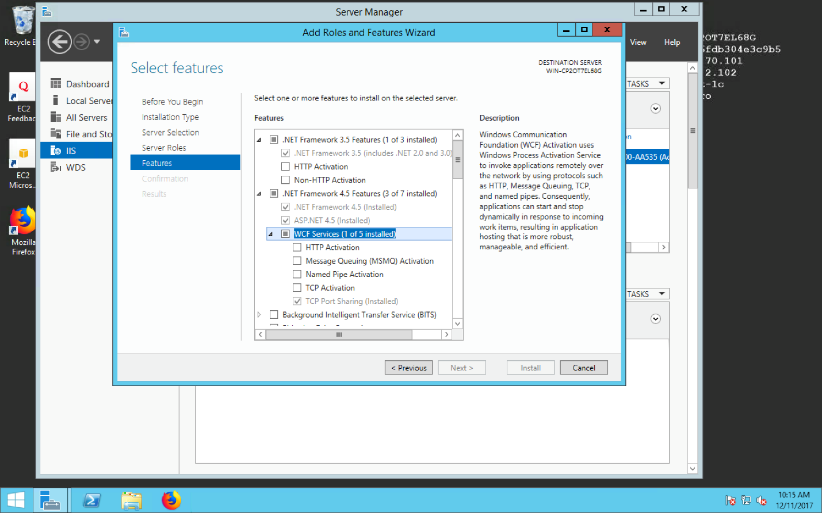

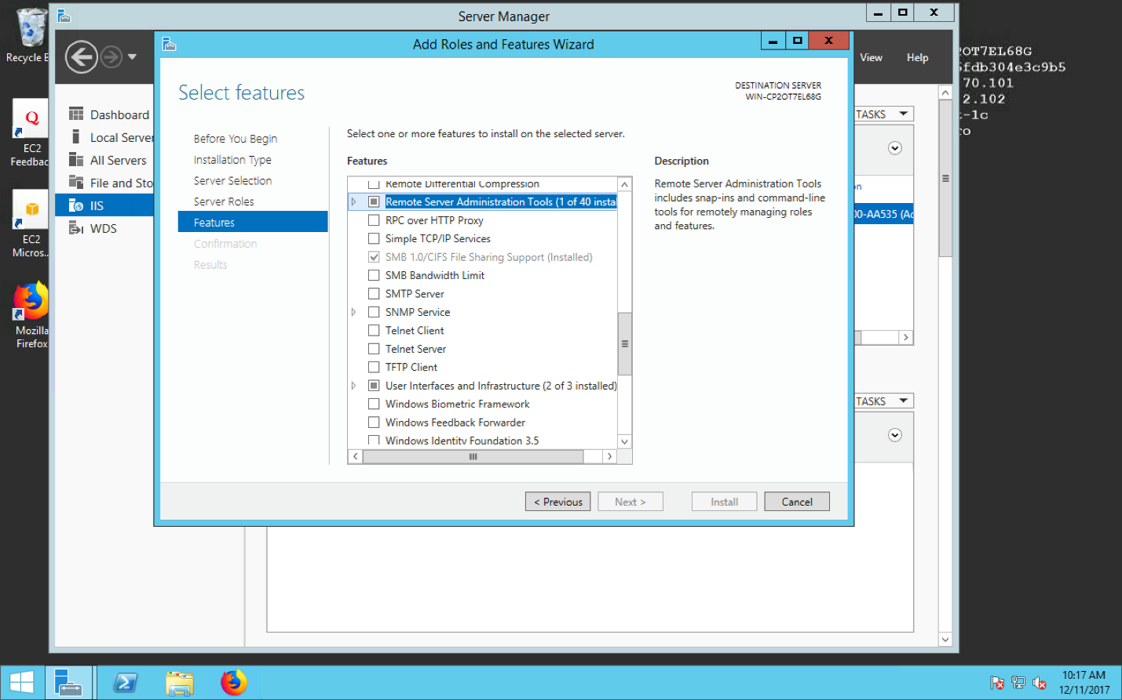

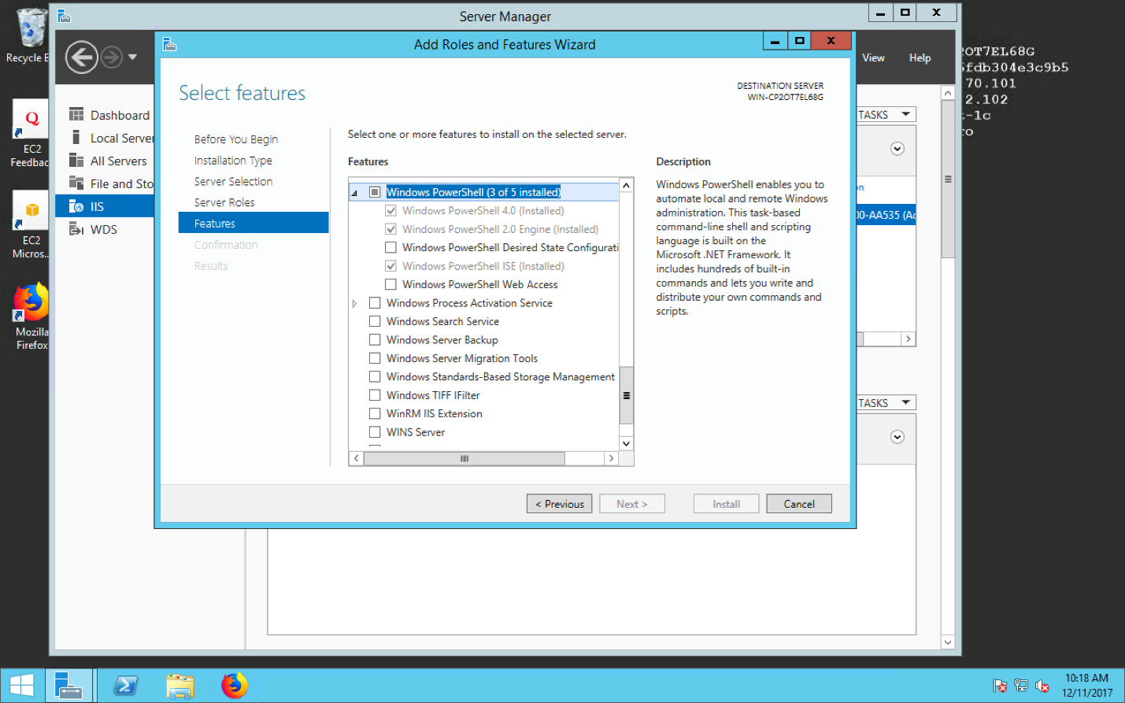

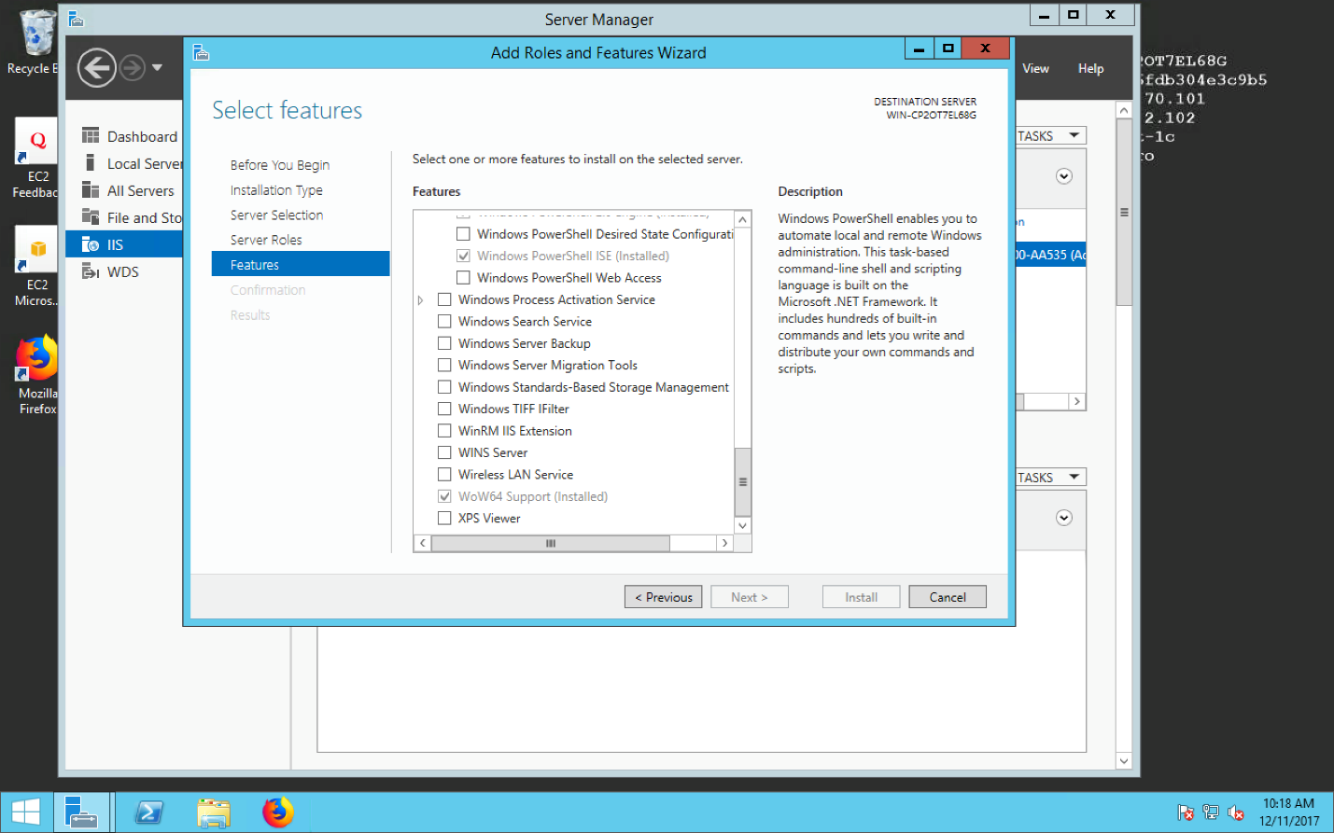

1. After that when you open IIS Manager on EC2 instance, you might see the alert box. It asks you to install Microsoft Web Platform. This software manages all the Microsoft Web products. Using this software, it is easy to search products and install them. Upon Clicking yes, it redirects to browser for installation.

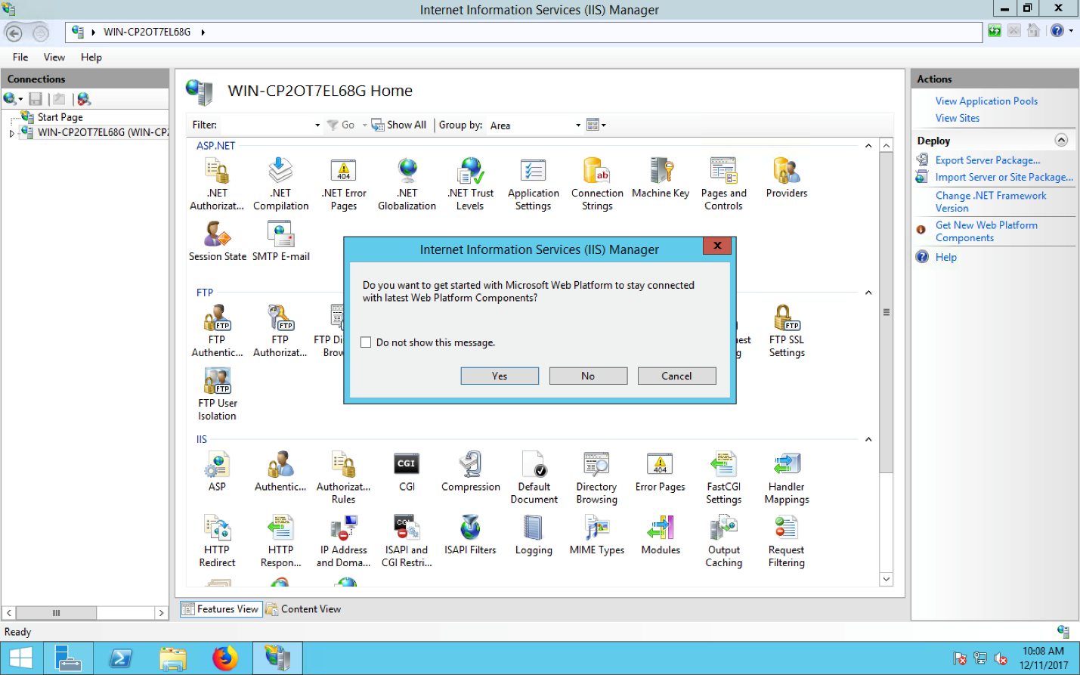

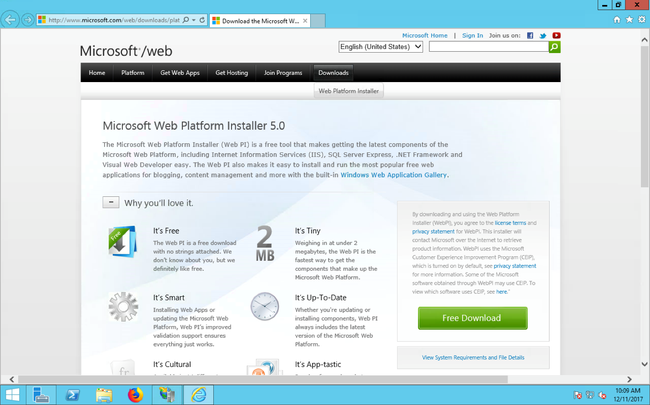

1. After installation, run MS Web Platform Installer inside IIS Manager to install Web Deploy and Web Deploy for Hosting Service 3.5, as shown in the screenshot below.

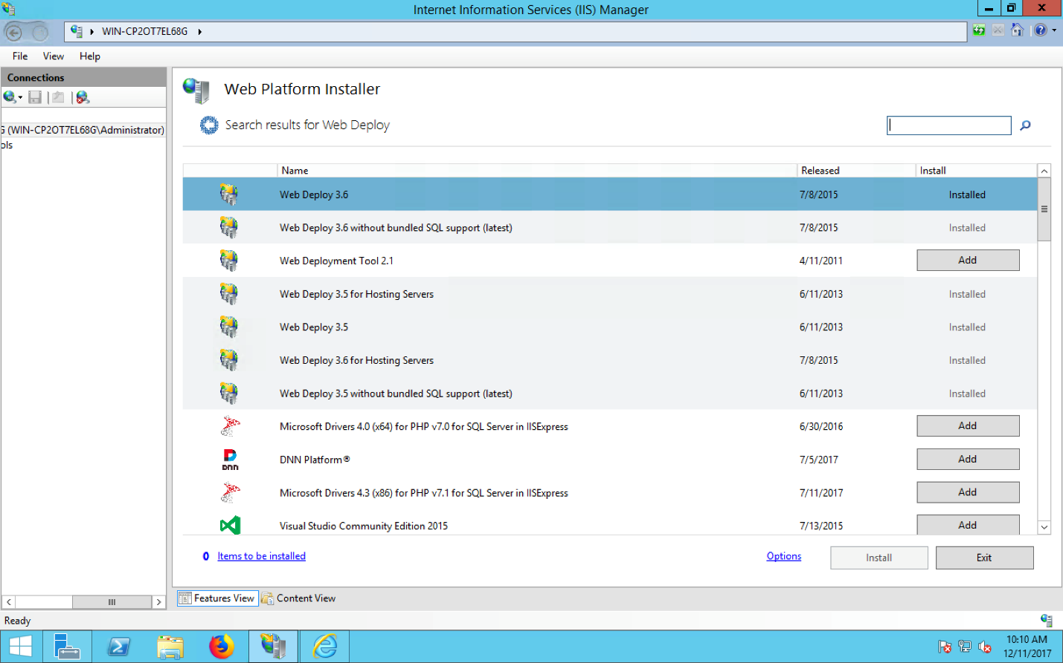

1. Then, you need to deploy your services/applications onto the EC2 server. To do that, create or open your application project in Visual Studio 2012 (or compatible versions). Make sure the DB URL in the Web.config file is the correct DB server communication endpoint. For example, the current URL is,

*<add connectionString="Data Source= mladatabase.cnb0lihdfsiq.us-west-1.rds.amazonaws.com,1433; Initial Catalog=MlaDatabase(****DATABASE NAME****); User ID=admin; Password=admin12345" name="MlaDatabase(****DATABASE NAME****)" providerName="System.Data.SqlClient" />*

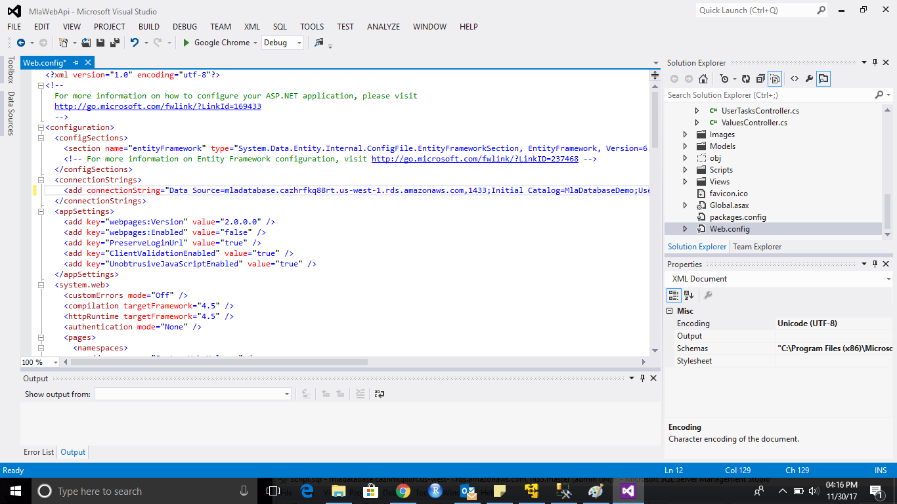

1. Follow the screen below to connect your Visual Studio with your Database Server. First open “Database Connections” tool from “Tools” menu. Adding connection, enter DB url (mladatabase.cnb0lihdfsiq.us-west-1.rds.amazonaws.com,1433), following that select “Use SQL Server Authentication”, add Username & Password. Select a Database from dropdown which you would like to connect.

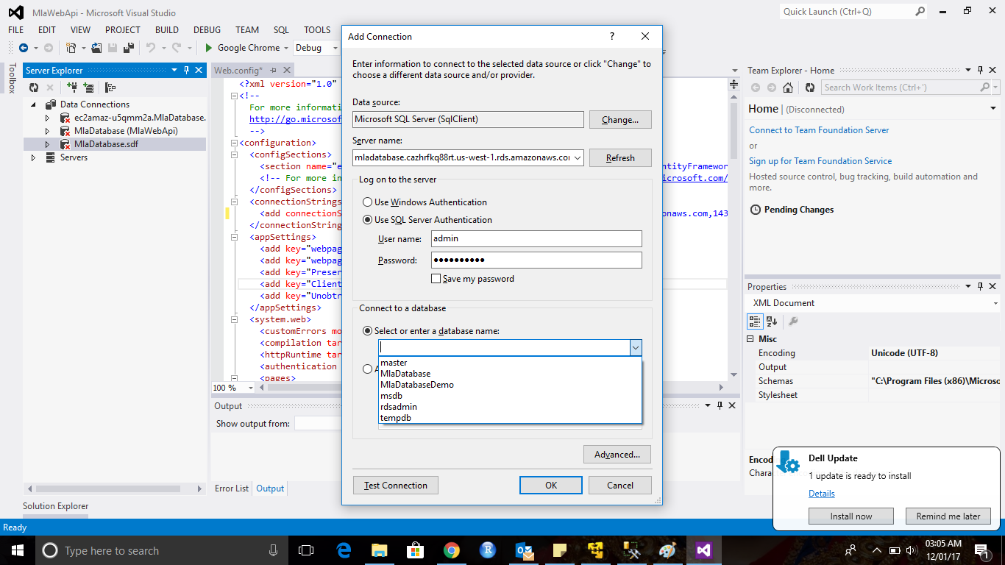

1. After selecting the database, perform Test Connection and verify your connection.

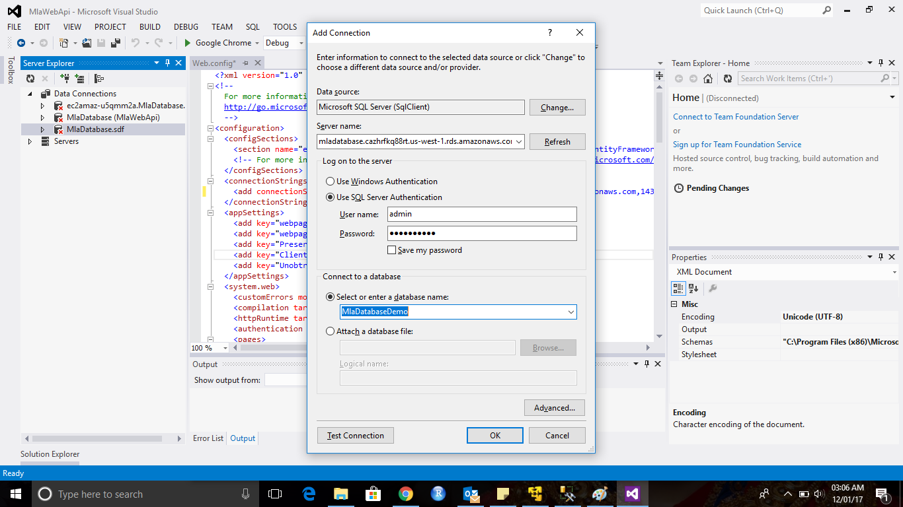

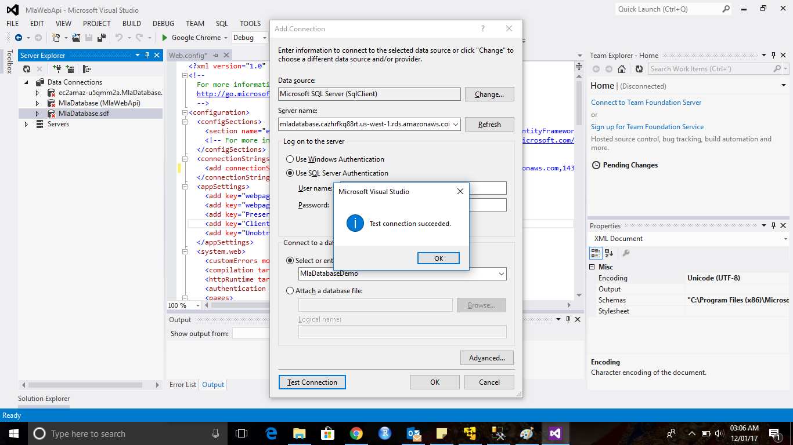

1. After building your application, publish it to the EC2 instance by making a right click on project from solution explorer.

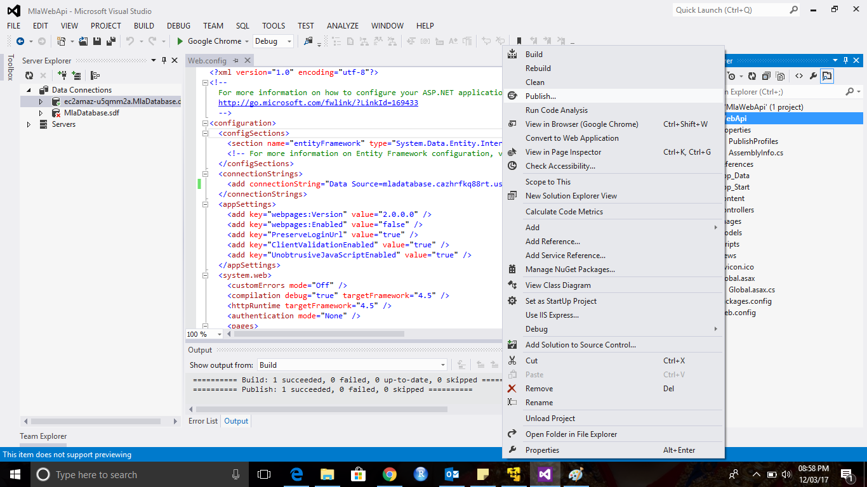

1. Follow the screens below to set up a new profile for your service.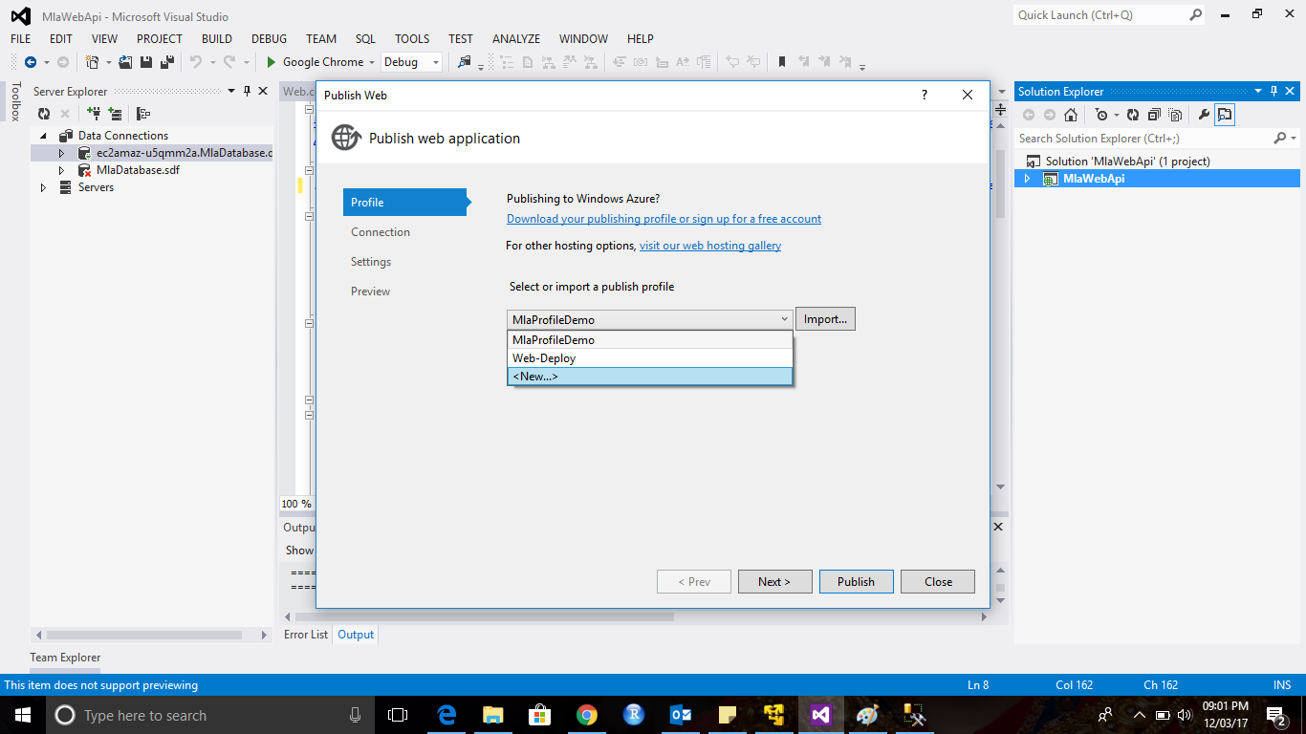

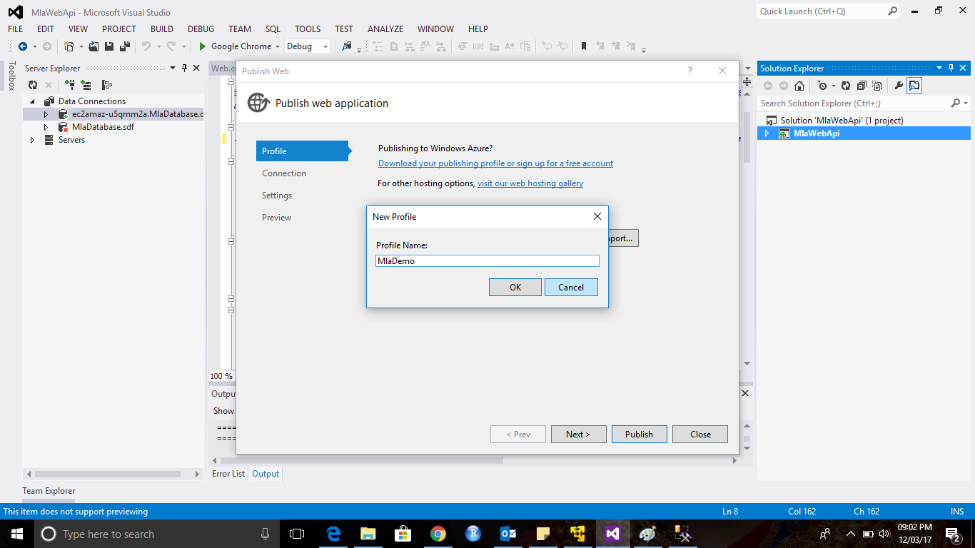

1. Follow the screen below to add the EC2 url and your EC2 account credentials. In “Site/application” field, always keep site name after “Default Web Site/ xxx” where “xxx” is the name of the Website or Webservice that will be the last part of the cloud service URL. At last, do “validate connection”. If the connection is established successfully, then press Next*.*

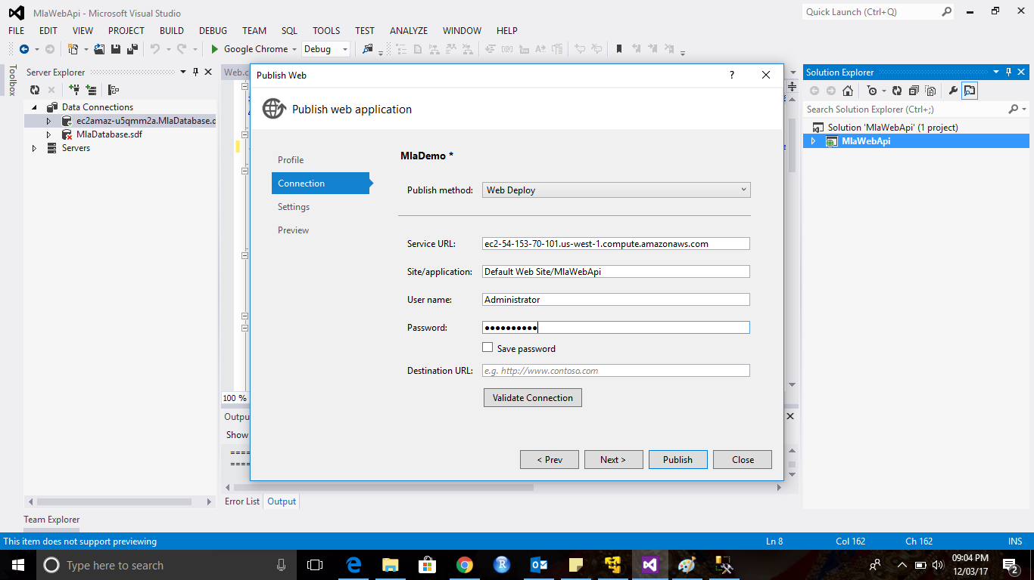

1. Add DB information. **DB URL:** Data Source= mladatabase.cnb0lihdfsiq.us-west-1.rds.amazonaws.com,1433; Initial Catalog=MlaDatabase(**DATABASE NAME**); User ID=admin; Password=admin12345 (copying from the setting from Web.config. Press Publish*.*

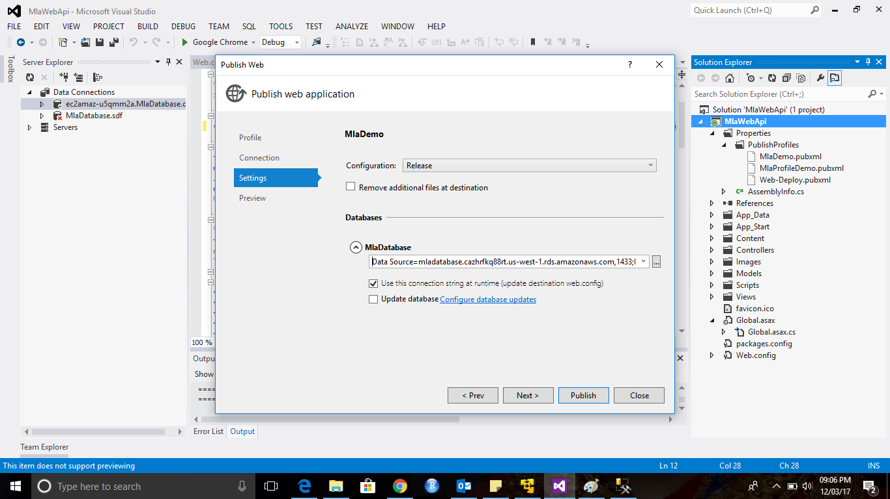

1. After deploying the application to server, you can see success message in console of Visual Studio. You can use “Remote Desktop Connection”. Go to your AWS EC2 machine and verify your application from “connections” panel in IIS Manager. The application should be under Default Web Site*.*

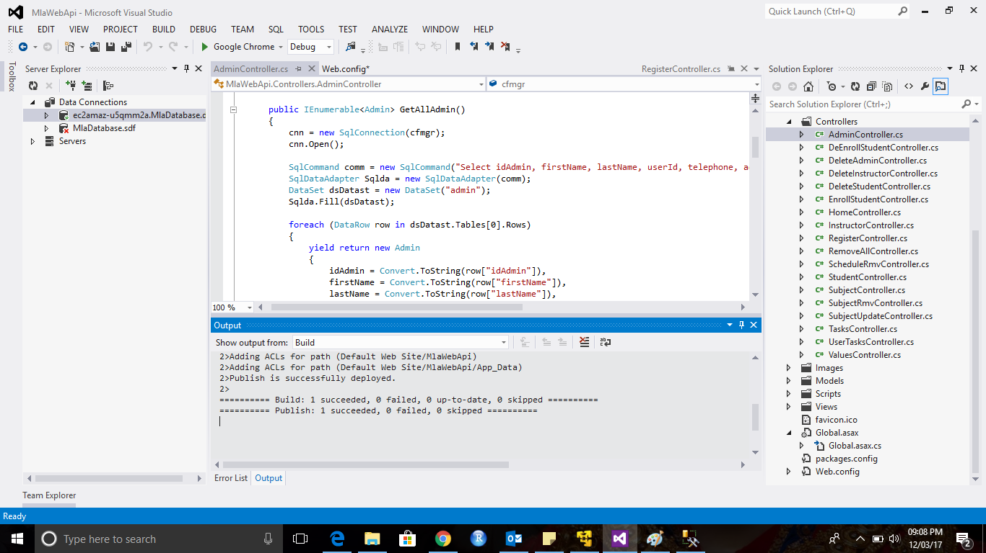

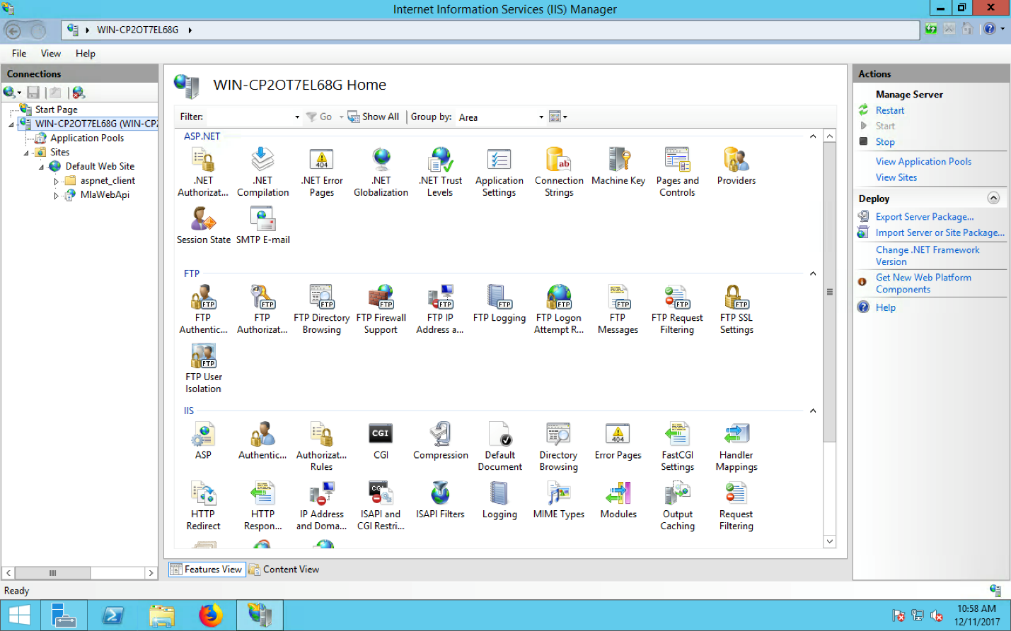

1. Note that you may experience errors when interacting with your service in the previous steps. If/when that happens, check if all of the DLL files are already installed on your EC2 instance. When you fail to interact with your service, check which of the .dll files are missing. If so, follow the screenshots below to install the missing DLL files.

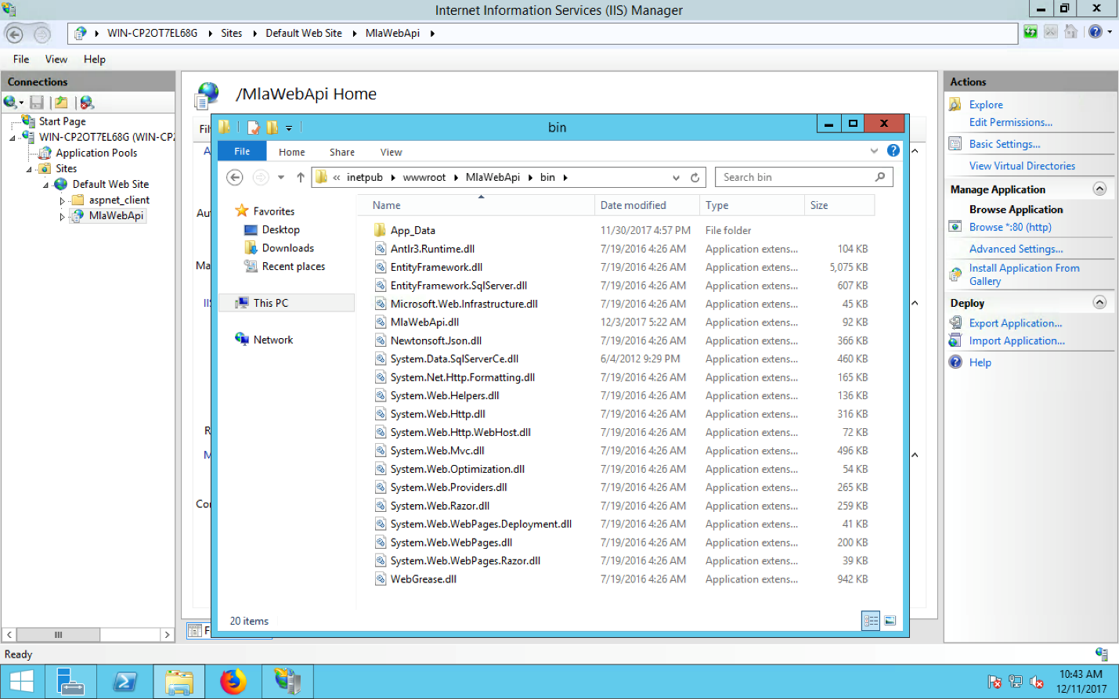

To add a .dll file, do a right click on references from solution explorer. The do “Add References”

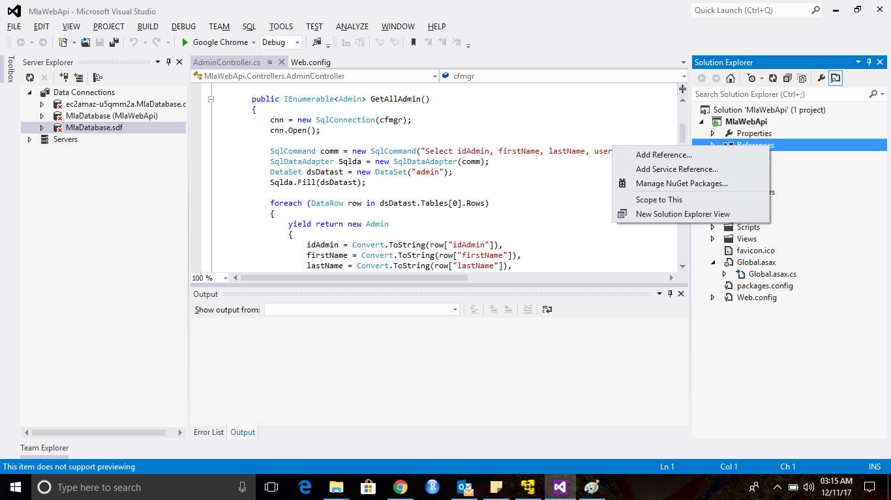

You can see a window with all .dll files. You can select the required files from here.

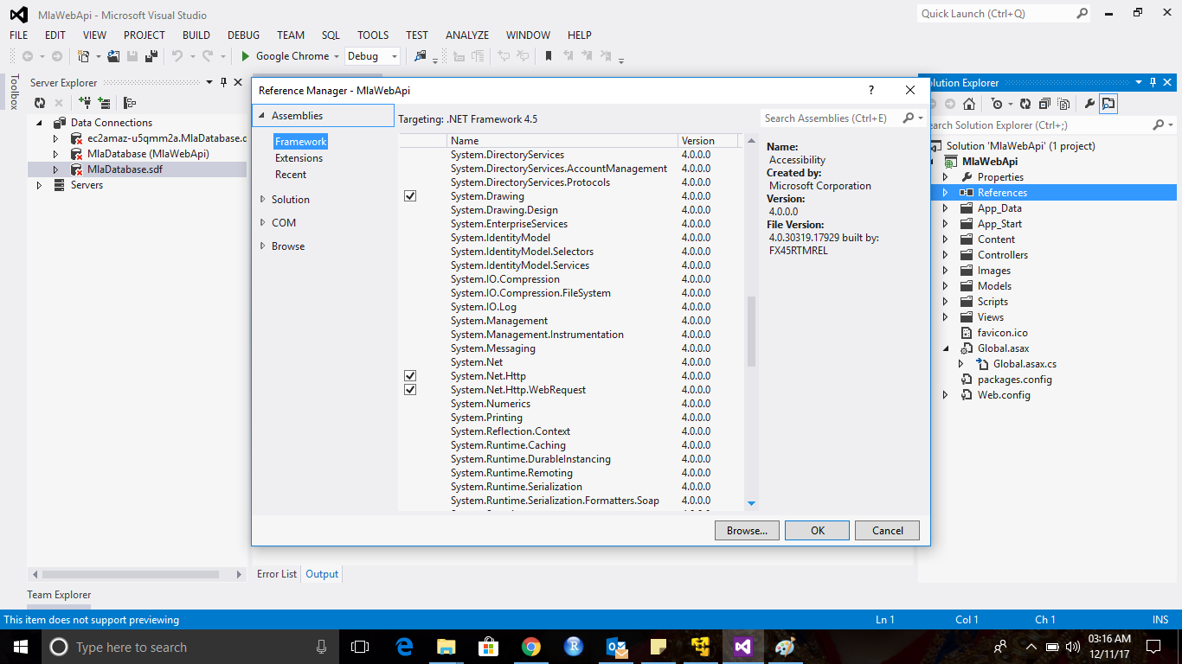

Once you select all the missing files. Expand “References” tab from solution explorer. For each missing DLL on AWS EC2, right click and select “properties”. Change “Copy Local” = True. Now clean and build again. Then deploy the API again. You should see all the missing .dll files at AWS EC2.

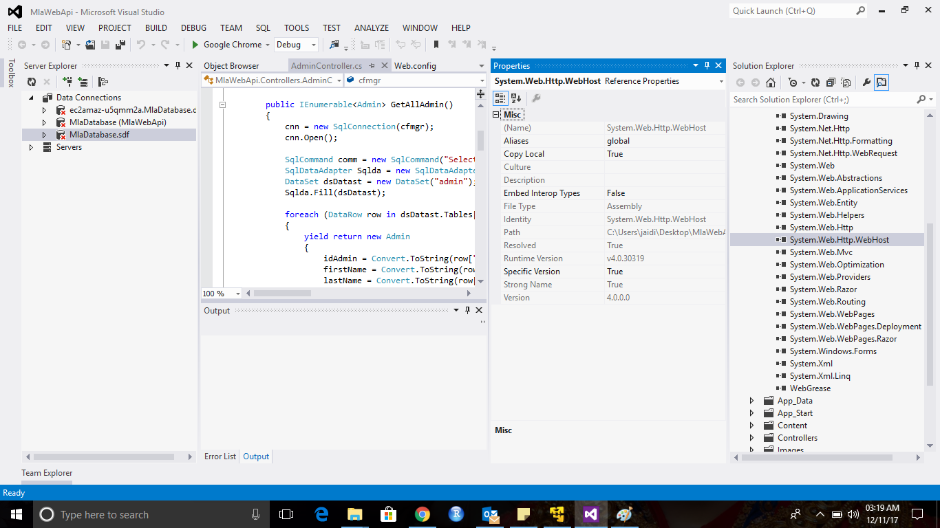

* **Test the REST API**

Now we need to test our API. For this I am using “Postman” application from Google Chrome browser. This application works as a client application. The application executes various type of requests, GET, POST, PUT, and etc. This section assumes that you have already these 2 APIs. The APIs are,

1. Fetch all the registered members from the Database (GET).

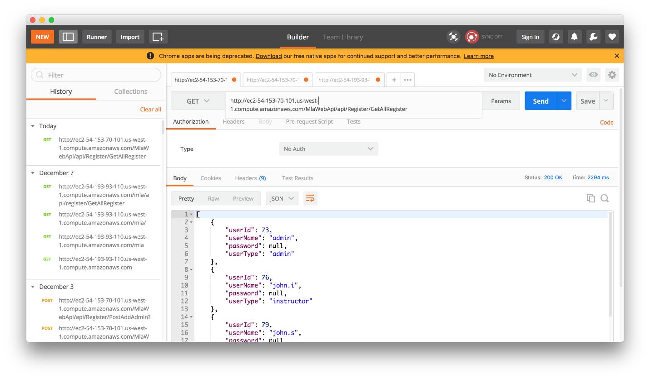

You should get blank output. If you don’t have any registered users.

1. Add an Admin / Add first admin (POST). You will receive a success response, if you will add all the parameters correctly.

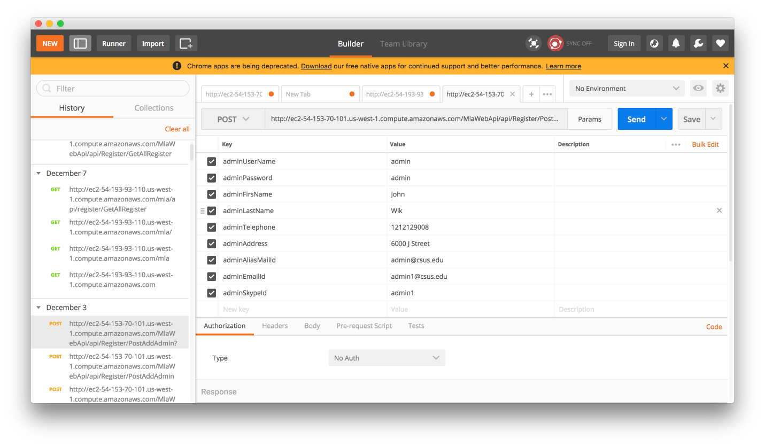

**FRONT END SETUP**

1. First unzip the source code.
2. Then open Android Studio 3.0. Select “Open an existing Android Studio Project”.

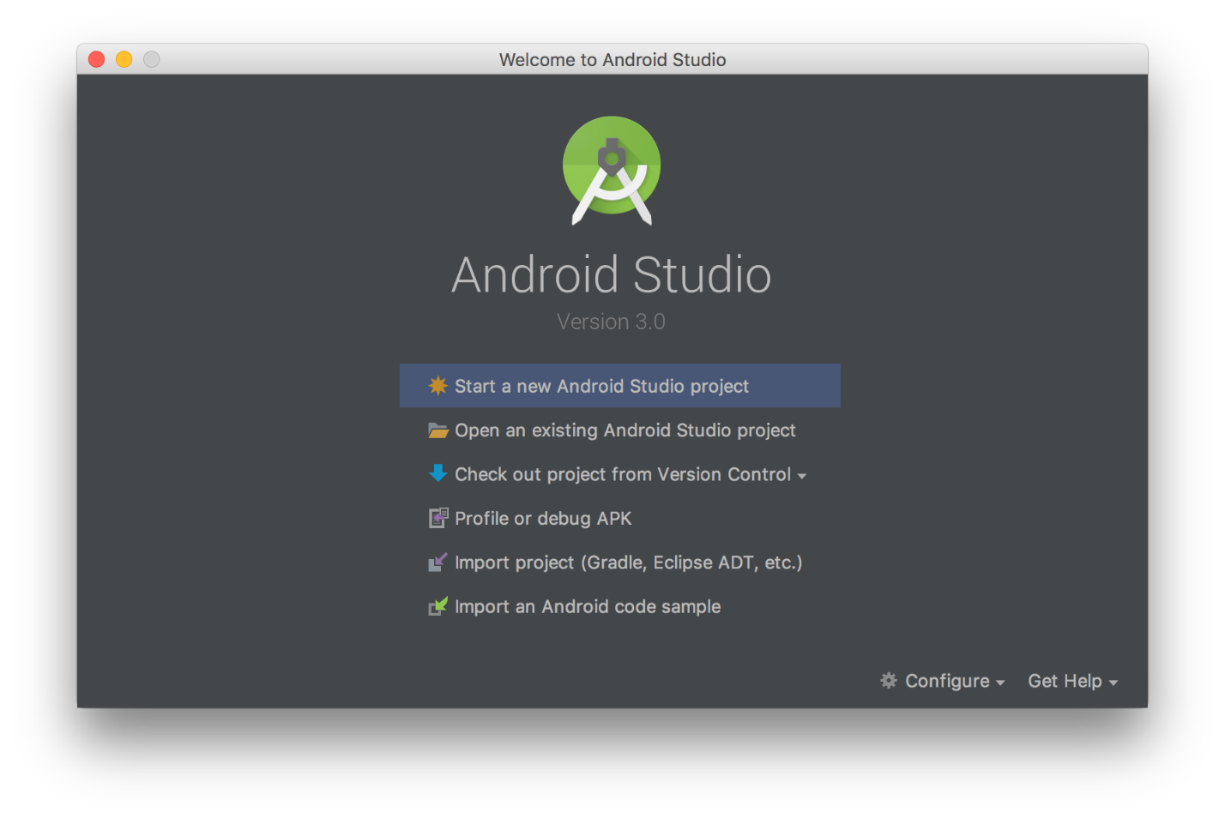

1. After that open your project from the path where you placed your source code.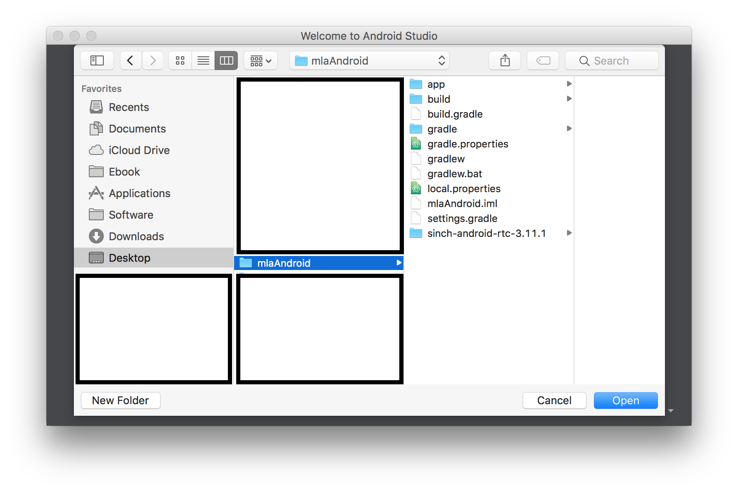
2. After that, allows gradle to sync with your project. This is a mandatory step. Wait till it is finished. 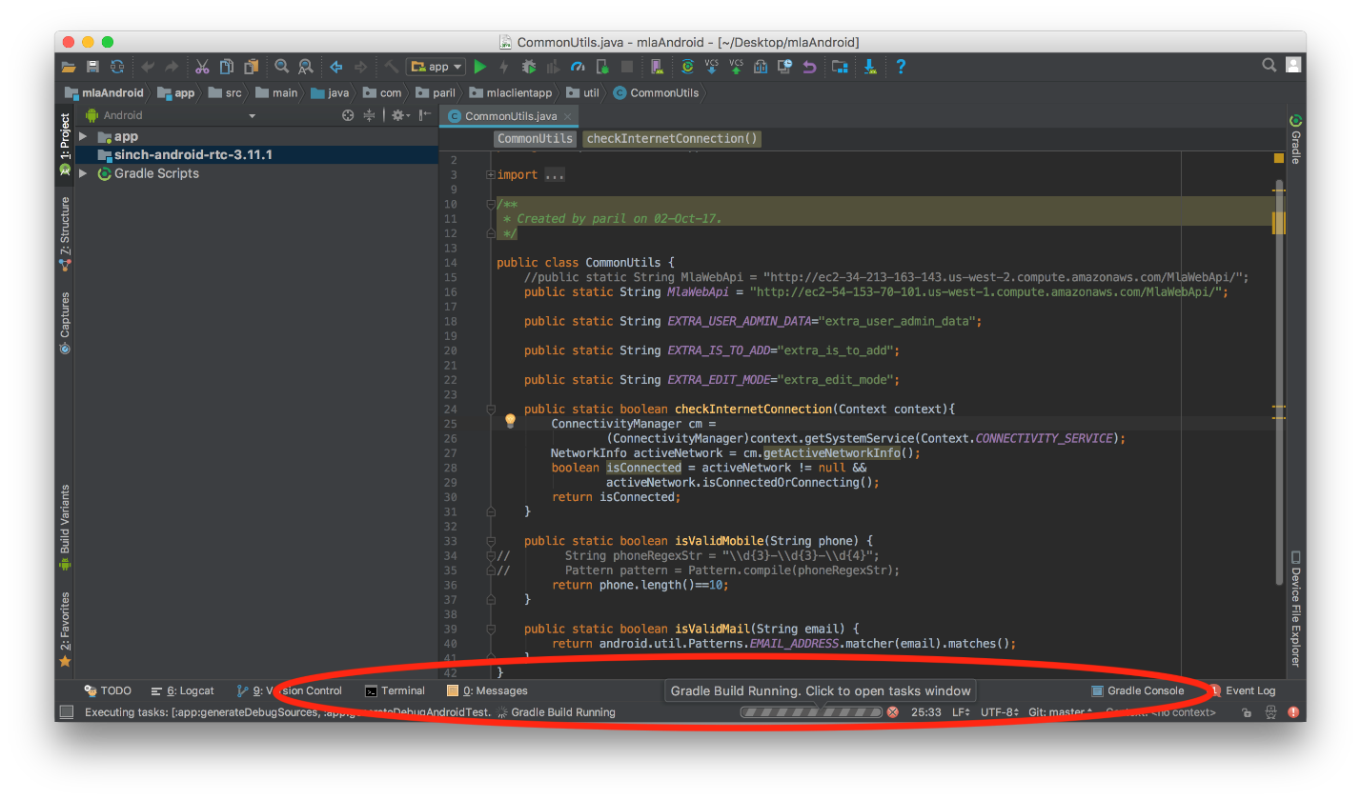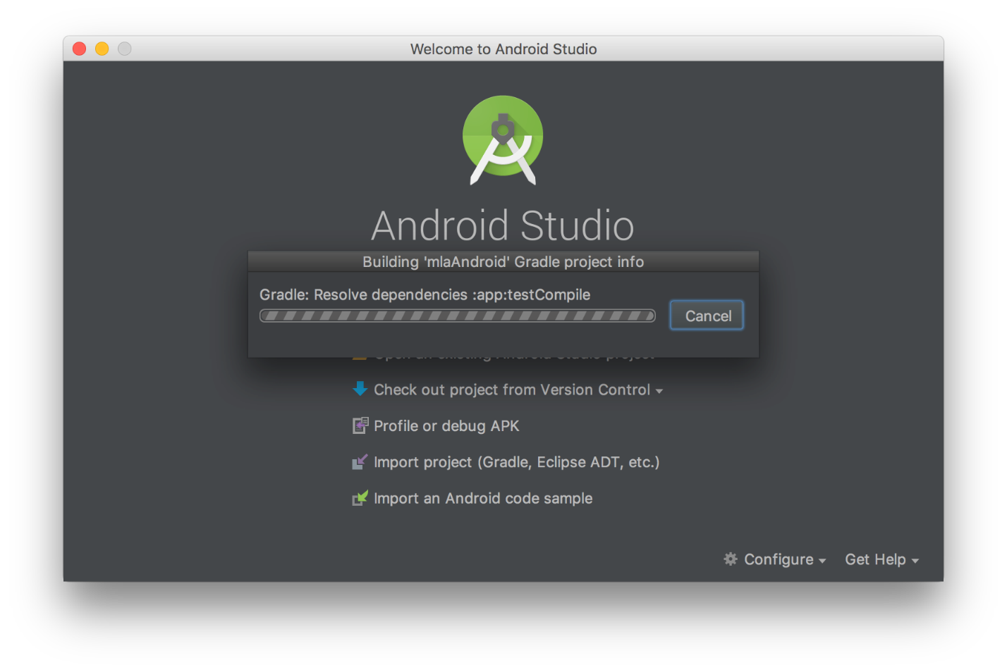
3. Open CommonUtils.Java file. The file is under com.paril.mlaclientapp -> util folder. and replace MlaWebApi string variable with yours url. Once you change that url, then run the project as shown in the screenshot.

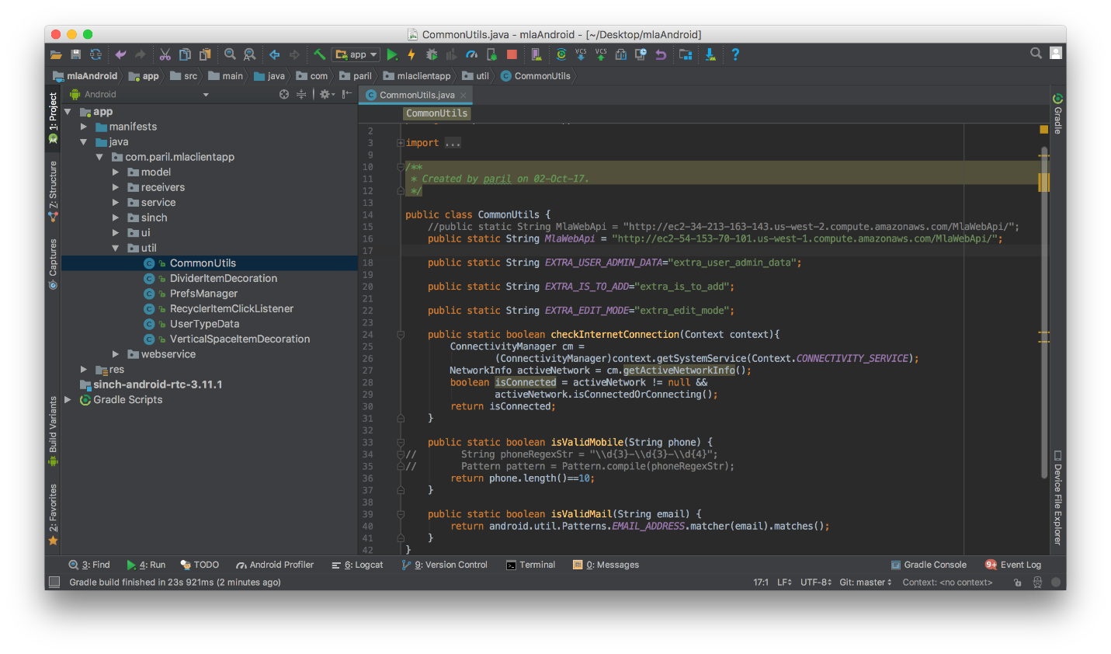

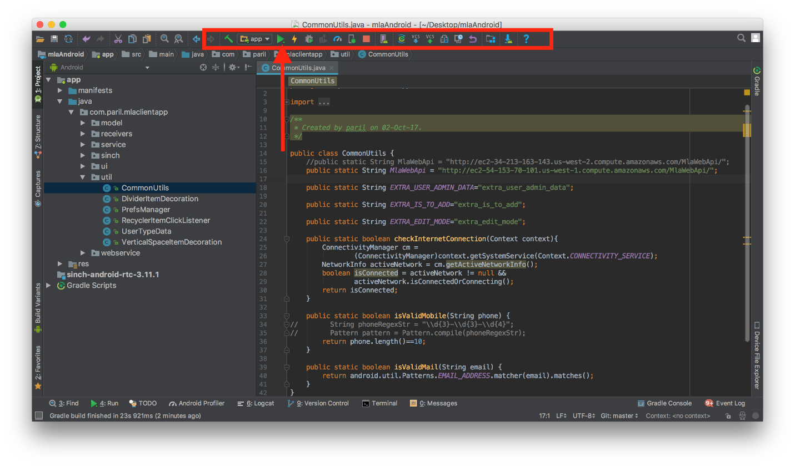

1. Once you select it then choose a deployment device. I am using Nexus 5 API 23. If you don’t have any device then, create new virtual device and install a new device. **NOTE**: AS I AM using SINCH SDK it does not allow me to run the application on Emulator. It is crashing on Emulator. I am still trying to identify the cause for this. So, I am using real device.

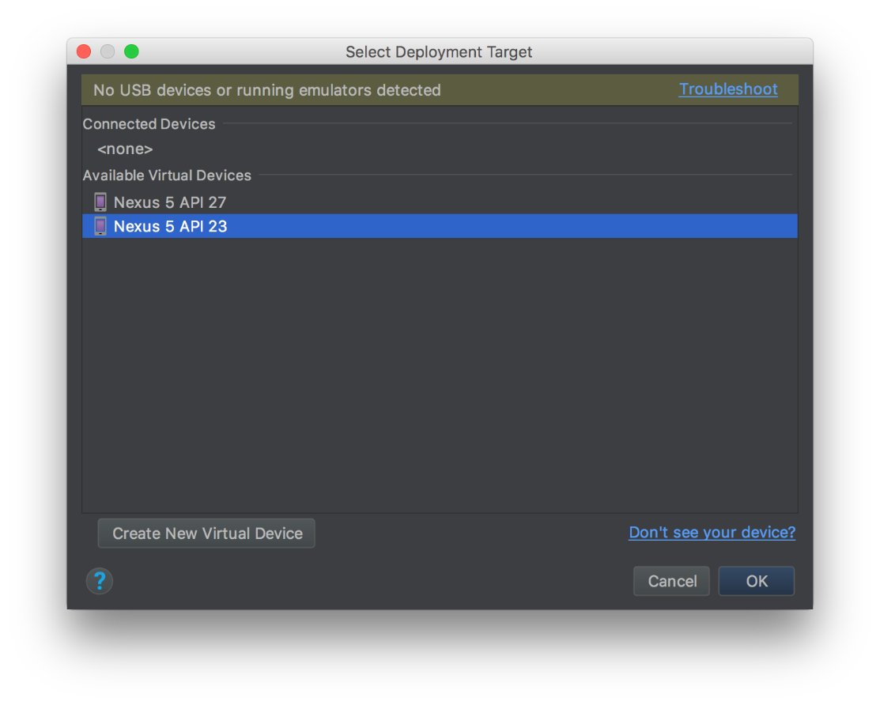

1. Upon pressing Ok, you should able to see Sign In screen of the application.

